თანამედროვე საქართველოს დემოლოგიური განვითარების ტენდენციები

ვაჟა ლორთქიფანიძე, საქართველოს მეცნიერებათა ეროვნული აკადემიის აკადემიკოსი, თსუ პროფესორი.
Email: Vazha.Lordkipanidze@tsu.ge
ანზორ სახვაძე, თსუ ასოცირებული პროფესორი.
Email: aSaxvadze@yahoo.com

აბსტრაქტი
სტატია წარმოადგენს თანამედროვე საქართველოში მიმდინარე დემოლოგიური განვითარების ძირითადი ტენდენციების განსაზღვრის მცდელობას. მასში გაანალიზებულია ბოლო ათწლეულებში საქართველოს მოსახლეობის რაოდენობის სისტემური კლების გამომწვევი მიზეზები. დეპოპულაციის ძირითად მიზეზად დასახელებულია შობადობის დონის დაცემა და ასევე, შრომითი ემიგრაციის საგრძნობლად გაზრდილი დონე. ნაჩვენებია აღნიშნული პროცესების გავლენა მოსახლეობის ასაკობრივ სტრუქტურაზე. ასაკობრივი სტრუქტურის გაუარესების შედეგად კიდევ უფრო მცირდება შობადობა და ქორწინებითი მდგომარეობა. აღნიშნულმა ტენდენციებმა მნიშვნელოვნად გაზარდა მოსახლეობის დემოლოგიური დაბერების მაჩვენებელი, ხოლო დემოლოგიური დაბერება კიდევ უფრო გაზრდის მოკვდაობას და შეამცირებს სიცოცხლის ხანგრძლივობას. ყოველივე ეს კი, ერთობლივად კიდევ უფრო აუარესებს მთლიან დემოლოგიურ ვითარებას. ამ გარემოებას ადასტურებს მოსახლეობის სქესობრივი სტრუტურისა და ქორწინების მაჩვენებლების ანალიზიც. მოსახლეობის საერთო რაოდენობაზე გავლენას ახდენს უჩვეულოდ გაზრდილი შრომითი ემიგრაციაც, რომელშიც უპირატესად ახალგაზრდა და რეპროდუქციული ასაკის მოსახლეობა მონაწილეობს.
ნაშრომში გამოთქმულია კონკრეტული მოსაზრებები საქართველოს მოსახლეობის რაოდენობის ჯერ სტაბილიზაციის, ხოლო შემდეგ ზრდის გრძელვადიანი სამოქმედო პროგრამების შემუშავების, კერძოდ, შობადობის სტიმულირებისა და შრომითი მიგრაციული პროცესების რეგულაციის შესახებ.
საქართველოში მოსახლეობის დეპოპულაციის პროცესი მიმდინარეობს იმ ფონზე, როდესაც ამის საპირისპიროდ დგას მსოფლიოს მოსახლეობის რიცხოვნობის კატასტროფულად ზრდის პრობლემა ‒ ყოველწლიურად მსოფლიოს მოსახლეობა, საშუალოდ 100 მილიონი ადამიანით იზრდება და ზრდის ტემპი თითქმის 1,6%-მდე აღწევს. სერიოზულ პრობლემებს ქმნის ისიც, რომ ასეთი ზრდა სრულიად არათანაბრად არის განაწილებული სხვადასხვა კონტინენტებისა და ქვეყნების მიხედვით: ზრდის 97% მოდის განვითარებად ქვეყნებზე, ხოლო ეკონომიკურად განვითარებულ ქვეყნებზე, ანუ ე.წ. დასავლეთზე მოდის ზრდის მხოლოდ 3%. ეს გარემოება რა თქმა უნდა, ხდება მსოფლიოში მიმდინარე ტექტონიკური მიგრაციული ძვრების, ინტენსიური მიგრაციული პროცესების ერთი უმთავრესი განმსაზღვრელი ფაქტორი. შობადობის მკვეთრი კლების პრობლემები განსაკუთრებით შესამჩნევია 1989 წლის შემდგომ დაბადებულთა თაობებისათვის. ქვეყანაში შობადობის დაცემამ და ამასთან ერთად, ასევე მკვეთრად გაზრდილმა შრომითმა ემიგრაციამ, შეამცირა მოსახლეობის სიმჭიდროვეც. 1990-იანი წლების დასაწყისში 1 კვ. კმ-ზე 82 კაცის ნაცვლად 2021 წელს მოსახლეობის სიმჭიდროვემ 65,2 კაცი შეადგინა.
1990-იანი წლების დასაწყისიდან, 2021 წლამდე შობადობის მკვეთრმა შემცირებამ გამოიწვია მოსახლეობის ასაკობრივი სტრუქტურის გაუარესებაც. გაიზარდა მოსახლეობის როგორც საშუალო, ასევე მედიანური და მოდალური ასაკებიც. მათი ზრდა მკაფიო ინდიკატორია და მიანიშნებს მოსახლეობის დაბერების სერიოზულ ზრდაზე. თანაც ეს დაბერება გამოწვეული ე.წ. „ქვემოდან დაბერებით“, ე.ი. შობადობის მკვეთრად შემცირებით და არა „ზემოდან დაბერებით“, ე.ი. სიცოცხლის ხანგრძლივობის ზრდით.
ამჟამად, საქართველოს მოსახლეობა, ისევე როგორც მსოფლიოს მოსახლეობა (დასავლეთ ევროპის, ამერიკის შეერთებული შტატების, იაპონიის და სხვა ქვეყნების) დემოლოგიურად დაბერებულია. გაეროს მიერ აღიარებული დემოლოგიური დაბერების შკალის მიხედვით, თუ 65 წლის და უფროსი ასაკის ადამიანების წილი მთელს მოსახლეობაში 7% და მეტია, მოსახლეობა დემოლოგიურად დაბერებულად ითვლება. საქართველოში კი ეს მაჩვენებელი თითქმის უკვე 15%-ია (მსოფლიო მაჩვენებელი 8%-ია). მოსახლეობის ასეთი დაბერების მიზეზი, შობადობის მკვეთრ შემცირებასთან ერთად შრომითი ემიგრაციის უჩვეულოდ გაზრდილი ინტენსივობაა, რომელშიც უპირატესად ახალგაზრდა, რეპროდუქციული ასაკისა და შრომისუნარიანი ადამიანები მონაწილეობენ. ამის გამო, ვფიქრობთ, უახლოეს წლებში დემოლოგიური დაბერების პროცესი კიდევ უფრო დაჩქარდება. თავის მხრივ, ეს ყველაფერი ქვეყნისთვის შექმნის კიდევ უფრო დიდ სოციალურ, ეკონომიკურ და პოლიტიკურ გამოწვევებს. აუცილებელია, მათ დასაძლევად ქვეყნის ხელისუფლებამ გაატაროს მეცნიერულად გააზრებული აქტიური სოციალური და დემოლოგიური პოლიტიკა. სერიოზული დაფიქრების საგანი უნდა გახდეს დემოლოგიური დატვირთვის კოეფიციენტების მკვეთრი გაუარესება, რომლებიც ასაკობრივი სტრუქტურის განმაზოგადებელი სიდიდეებია. ისინი საზოგადოების არამწარმოებლური მოსახლეობით დატვირთვას გვიჩვენებენ.
საანალიზო პერიოდში დაბადებულთა აბსოლუტური რაოდენობის შემცირებასთან შედარებით, უფრო მეტად დაიკლო საქართველოს მოსახლეობის საშუალო წლიურმა ოდენობამ. შობადობის დამახასიათებელ მაჩვენებლებს შორის მნიშვნელოვანია სქესთა მეორეული თანაფარდობის ცვლილებაც, რომლის დინამიკაც იმაზე მეტყველებს, რომ ეს მაჩვენებელი თითქმის უმნიშვნელოდ იცვლებოდა და ბუნებრივია, მომავალში ის დიდ გავლენას ვერ მოახდენს, ვერც მოსახლეობის გამრავლების რეჟიმზე და ვერც სქესობრივ-ასაკობრივ შემადგენლობაზე, რაც ასევე მნიშვნელოვანია.
საყურადღებოა, რომ ბოლო 30 წლის განმავლობაში, საქართველოში საგრძნობლად შემცირდა 20 წლამდე ასაკის ქალების მმოიერ გაჩენილი ბავშვების რაოდენობა და გაიზარდა 30 წელს გადაცილებულ ქალთა მიერ გაჩენილი ბავშვების რაოდენობა, ე.ი. გაიზარდა გვიანდელი მშობიარობების რაოდენობა, რაც უთუოდ შობადობის კიდევ უფრო შემცირების მიზეზი გახდება.
შობადობის დონის სრულყოფილად დახასიათებისათვის დიდი მნიშვნელობა აქვს დაბადებულ ბავშვთა რიცხოვნობის დინამიკას, დაბადებათა რიგითობას. სამწუხაროდ, ჩვენი კვლევები აჩვენებს, რომ საქართველოში ეს მნიშვნელოვანი მაჩვენებლებიც გაუარესებულია.
ყოველივე ეს, ქვეყანაში მიმდინარე დემოლოგიური პროცესები სერიოზულ ამოცანებს უყენებს საქართველოს ხელისუფლებას. გადაუდებლად აუცილებელია მეცნიერულად დასაბუთებული სოციალური და დემოლოგიური პოლიტიკის გატარება ქვეყნის სამეცნიერო პოტენციალისა და ფართო საზოგადოების მონაწილეობით.

საკვანძო სიტყვები: მოსახლეობა, შობადობა, მოკვდაობა, შრომითი მიგრაცია, ასაკი, დაბერება, ქორწინება.

Trends in Demological Development in Modern Georgia

Abstract
The present paper is an attempt to identify the main trends in the demological development of modern Georgia. It gives the analysis of the reasons for the regular population decline in Georgia in recent decades. The main cause of depopulation in the country is considered to be decreased natality, as well as significantly increased labor emigration. The influence of the aforementioned processes on the age structure of the population is illustrated in the present article. The worsened age structure has resulted in a further decline in the birth rate and deterioration of marital status. These trends have significantly increased the rate of demological aging of the population, which will further increase mortality and decrease life expectancy. All these factors combine to deteriorate the overall demological status what is confirmed by the analysis of the sex structure and marital status indices of the population. Another factor affecting the overall number of the population is the unusually increased labor emigration, mainly of the people of young and reproductive age.
The article gives specific views on the development of long-term action programs first to stabilize and then to increase the population of Georgia, in particular to stimulate the birth rate and regulate labor migration processes. The depopulation process in Georgia occurs against the background of a catastrophic growth of the global population showing average 100 million annual increase making almost 1.6% growth rate.
Another serious issue is that the population growth rate varies greatly across different continents and countries: 97% of the growth is fixed in developing countries, while developed economies, so called the West, show only 3% growth. This fact is undoubtedly becoming one of the most important determinants of migration movements and intensive migration processes in the world. The problems of a sharp decline in the birth rate are especially noticeable for the generations born after 1989. The fall in the birth rate in Georgia, coupled with sharply increased labor emigration, has reduced population density. In the early 1990s, population density per square kilometer was 65.2 against 82 in 2021.
From the early 1990s to 2021, the sharp decline in natality deteriorated the age structure of the population. The mean, median and modal ages of the population have also increased. Their increase is a clear indicator of a great increase in population aging, which is also caused by so-called “aging from below”, i.e. by a sharp decline in natality, rather than “aging from above”, i.e. by an increase in life expectancy.
The population of Georgia, like the population of other countries in the world (Western Europe, the United States of America, Japan, etc.), is currently demologically aging. According to the scale of demographic ageing accepted by the UN, if the proportion of people aged 65 and over in the total population is 7% or more, the population is considered to be demologically aging. In Georgia this rate is already close to 15% (the world average is 8%). The reason for such aging of the population, along with sharply declined birth rate, is unusually intense labor emigration mainly of people of young, reproductive and working age. Consequently, it must be assumed that the process of demological aging will accelerate further in the coming years. This state will generate even greater social, economic and political challenges for the country. In order to overcome them, the government of Georgia needs to pursue a scientifically sound and active socio-demographic policy. The sharp deterioration of demological load coefficients, which are generalized values of age structure, should be the subject of serious attention. They show the burden of society by non-productive population.
Compared to the decline of the absolute number of births in the analyzed period, the average annual population of Georgia has decreased more. Changes in the secondary sex ratio are one of the important characteristic indices of natality. Their dynamics suggest that this indicator has changed very little and in the future, its influence on the birth rate regime and sex-age structure of the population will naturally be little what is also very important.
It is noteworthy that over the past 30 years, in Georgia the number of children born to women under 20 years decreased significantly and the number of children born to women over 30 years increased, i.e. the number of late births increased what will undoubtedly cause a further decline in the birth rate.
The dynamics of the number and order of births are very important for the comprehensive characterization of the birth rate.
Unfortunately, our studies show that even these important indices have deteriorated in Georgia. The above-described demological processes taking place in the country place serious challenges before the Government of Georgia. There is urgent need for a scientifically based socio-demological policy, by applying the scientific potential and involving the general public of the country.

Key words: Population, natality, mortality, labor migration, age, aging, marriage.

შესავალი
ბოლო ათწლეულებში საქართველოში ჩამოყალიბდა რთული კრიზისული დემოლოგიური სიტუაცია. ასეთი ვითარების ჩამოყალიბება მნიშვნელოვანწილად განაპირობა იმ პოლიტიკურმა და სოციალურ-ეკონომიკურმა პროცესებმა, რომლებიც განვითარდა ახალი, დამოუკიდებელი საქართველოს ჩამოყალიბების პერიოდში. უაღრესად მძიმე იყო სამოქალაქო დაპირისპირებისა და ტერიტორიული მთლიანობისათვის ბრძოლის დემოლოგიური შედეგები. სამწუხაროდ, როგორც 1990-იან წლების დასაწყისში, ასევე 2008 წელს რუსეთის მიერ განხორციელებული და ხელშეწყობილი აგრესიის შედეგად გამოწვეულმა ადგილობრივი მოსახლეობის იძულებითმა, ძალადობრივმა მიგრაციულმა პროცესებმა დემოლოგიური ვითარება ქვეყანაში უკიდურესად გაამწვავა. ყოველივე ამის შედეგია სწორედ საქართველოს მოსახლეობის რაოდენობის სისტემატური და საგრძნობი კლება, შობადობის დონის მკვეთრი დაცემა, ასაკობრივი სტრუქტურის, ქორწინებითი მდგომარეობის გაუარესება. სწრაფად გაიზარდა მოსახლეობის დემოლოგიური დაბერების მაჩვენებლები. დემოლოგიური ვითარების გაუარესებაზე უარყოფით გავლენას ახდენს უჩვეულოდ გაზრდილი შრომითი ემიგრაციაც. უკვე თითქმის სამი ათწლეულია (გარდა 2022-2023 წლებისა, როდესაც საქართველოში მოსახლეობის რიცხოვნობის უმნიშვნელო ზრდა ─ 47,8 ათასი კაცი, დაფიქსირდა) საქართველოს მოსახლეობა ქრონიკულ დეპოპულაციას განიცდის (იხ. გრაფიკი 1¹).

გრაფიკი N1: საქართველოს მოსახლეობის რიცხოვნობა 2023 წლის 1 იანვრის მდგომარეობით, ათასი
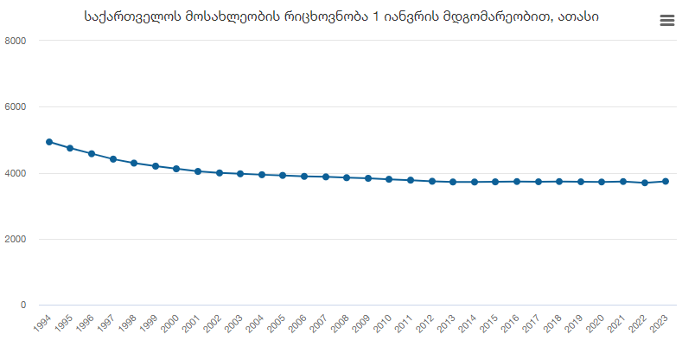

ამ გრაფიკზე ნათლად ჩანს, რომ სახეზეა უწყვეტი დეპოპულაცია, რომელიც თავისი ხასიათითა და ხანგრძლივობით მდგრადი და გრძელვადიანია, ხოლო განვითარების ტიპით ─ თითქმის თანაბარი.
აღნიშნული დემოლოგიური განვითარებით საქართველო არ ჯდება მსოფლიოს დემოლოგიური განვითარების ტენდენციებში. საქართველოსაგან განსხვავებით, თანამედროვე სამყაროში მოსახლეობის რიცხოვნობა ძალიან სწრაფად იზრდება. უკანასკნელ წლებში მატების წლიური ტემპი საშუალოდ 1,0-1,6%-მდეა. ძალიან დიდია მოსახლეობის აბსოლუტური მატების სიდიდე. მაგალითად, 2020 წელს მსოფლიოს მოსახლეობამ 1%-ით მოიმატა, რაც აბსოლუტურ რიცხვებში ნიშნავს, რომ 2020 წელს დედამიწის მოსახლეობას 82,3 მლნ ადამიანი შეემატა. ამათგან მხოლოდ 3 მლნ (ანუ 3,5%) ახალშობილი იყო განვითარებული ქვეყნებიდან, ხოლო 82 მლნ (ანუ 96,5%) კი —განვითარებადიდან. სხვაგვარად რომ ვთქვათ, ეს იმასაც ნიშნავს, რომ მარტო 2020 წლის განმავლობაში მსოფლიოს შეემატა გერმანიის მოსახლეობის (82,3 მლნ) ოდენი ადამიანი.
სხვაგვარად დგას საკითხი საქართველოს დემოლოგიურ განვითარებასთან დაკავშირებით, რომელიც თავისი მოსახლეობით, მცირერიცხოვანი სახელმწიფოა და როგორც აღვნიშნეთ, რამდენიმე ათწლეულია გამოირჩევა დეპოპულაციის საკმაოდ სტაბილური მაჩვენებლებით.
მოსახლეობის რიცხოვნობის ამგვარი დინამიკა ქვეყნის დემოლოგიური განვითარების ხანგრძლივ კრიზისულ ტენდენციაზე მიანიშნებს. ეს კარგად ჩანს სქესობრივ-ასაკობრივ პირამიდაზე არსებული ღრმულების მეშვეობითაც (იხ. გრაფიკი 2¹).

გრაფიკი N2: სქესობრივ-ასაკობრივი პირამიდა 2023 წლის 1 იანვრის მდგომარეობით, ათასი
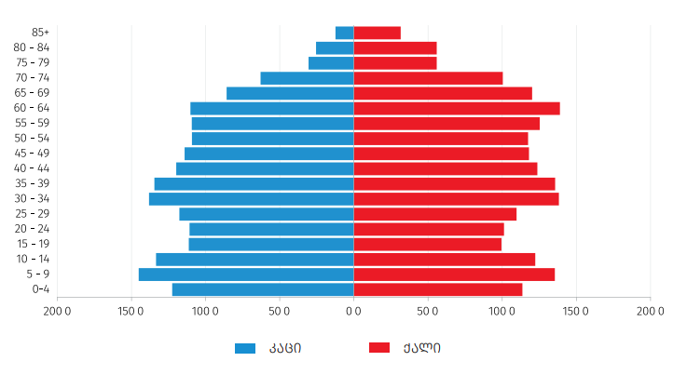

ეს ტენდენცია განსაკუთრებით თვალშისაცემია 1989 წლის შემდგომ დაბადებულ, ანუ ამჟამად 30-34 წლის ასაკობრივი ჯგუფის მომდევნო ახალგაზრდულ თაობებში და, ძირითადად შობადობის ინტენსივობის კლებითაა განპირობებული.
საქართველოში შობადობის დონის დაცემამ და ამასთან ერთად, შრომითი ემიგრაციის უჩვეულოდ დიდმა მასშტაბებმა, ბუნებრივია, შეამცირა მოსახლეობის სიმჭიდროვეც, რაც კარგად ჩანს 3¹ გრაფიკზე. მოსახლეობის სიმჭიდროვემ, 1994 წელს 1 კვ. კმ-ზე არსებული 82 კაცის ნაცვლად 2023 წელს 65,3 კაცი შეადგინა (აფხაზეთისა და ე.წ. სამხრეთ ოსეთის ტერიტორიების გათვალისწინებით), ე.ი. 20,4%-ით დაიკლო.

გრაფიკი N3: მოსახლეობის სიმჭიდროვე 1 კვ. კმ-ზე
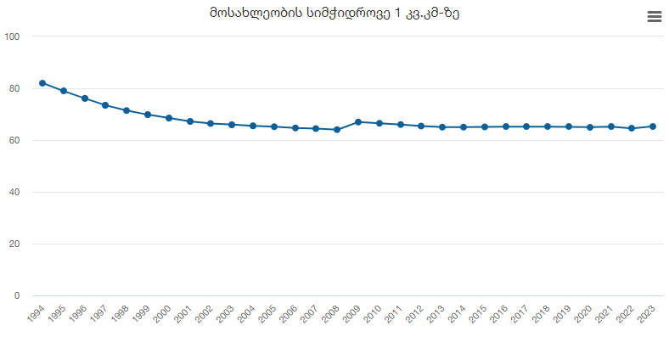

უკანასკნელ 30 წელიწადში განვითარებული ნეგატიური დემოგრაფიული პროცესები აისახა მოსახლეობის ასაკობრივი სტრუქტურის ისეთ განმაზოგადებელ მაჩვენებელზეც, როგორიცაა მედიანური ასაკი. თუ 1994 წელს მედიანური ასაკი ორივე სქესისათვის 32 წელს (ვაჟებში ─ 29,4 და ქალებში ─ 33,7 წელს) უდრიდა, უკვე 2023 წლის 1 იანვრისათვის მისმა სიდიდემ 38 წელს (ვაჟებში ─ 35,2 და ქალებში ─ 40,1 წელს) მიაღწია, ე.ი. 18,8%-ით (ვაჟებში ─ 19,7%-ით და ქალებში ─ 19,0%-ით) მოიმატა (იხ. გრაფიკი 4¹).

გრაფიკი 4: მოსახლეობის მედიანური ასაკი, წელი
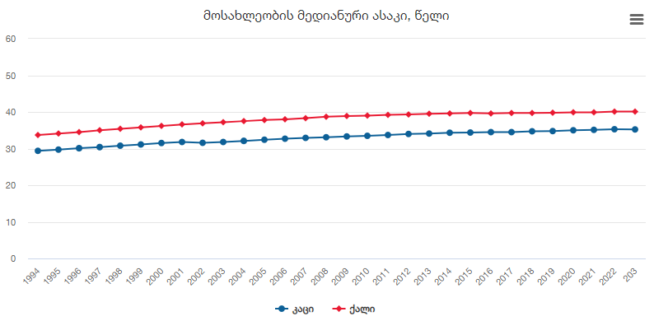

მოსახლეობის მედიანური ასაკის ასეთი სწრაფი ზრდა, როგორც დემოგრაფიული დაბერების მკაფიო ინდიკატორი, მიანიშნებს, რომ ასაკობრივი სტრუქტურის გაუარესების ხარჯზე დემოგრაფიული პროცესები კიდევ უფრო გართულდება. კერძოდ, შემცირდება შობადობა, ქორწინებათა რაოდენობა, ხოლო დემოგრაფიული დაბერების გამო გაიზრდება მოკვდაობის დონე და შემცირდება მოსალოდნელი სიცოცხლის საშუალო ხანგრძლივობა, რაც საბოლოო ჯამში გამოიწვევს თაობათა სწრაფ ცვლას.
დემოგრაფიული დაბერების დონე, რომლის დინამიკაც 5¹ გრაფიკზეა ნაჩვენები, აშკარად მეტყველებს მის თითქმის განუხრელ ზრდაზე (რომლის სიდიდემაც ორივე სქესისათვის 1994 წელს არსებული 10,5%-ის ნაცვლად თითქმის 5.1 პროცენტული პუნქტით მოიმატა და 2023 წელს 15,6% შეადგინა) და მიანიშნებს, რომ აქ, ძირითადად, მოსახლეობის ე.წ. „ქვემოდან დაბერებას“ (ანუ როდესაც მთელ მოსახლეობაში 65 წლისა და უფროსი ასაკის მოსახლეობის წილი იზრდება შობადობის დონის შემცირების გამო) აქვს ადგილი.

გრაფიკი N5: 65 წლისა და უფროსი ასაკის მოსახლეობის წილი მთელ მოსახლეობაში, %
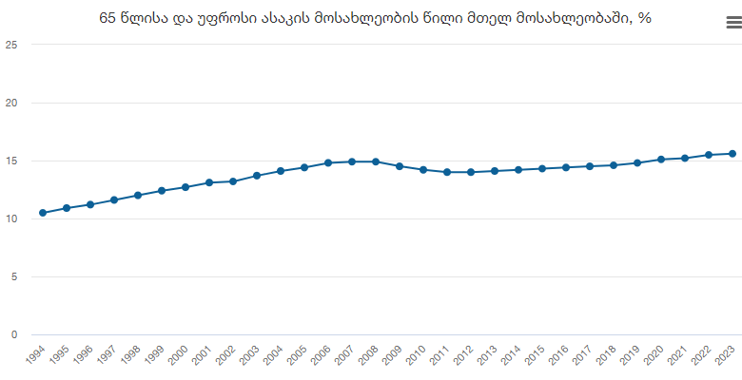

გაეროს ექსპერტების მიერ შემუშავებული სამსაფეხურიანი სკალის შესაბამისად, ამჟამად საქართველოს მოსახლეობა, ისევე როგორც დასავლეთ ევროპის, იაპონიისა და აშშ-ს მოსახლეობაც, დემოგრაფიულად საკმაოდ „დაბერებულია“. ამასთან, საქართველოშიც, როგორც ნებისმიერ სხვა ქვეყანაში, დემოგრაფიულ დაბერებას ხელს უწყობს სწორედ საანალიზო პერიოდში მკვეთრად გაუარესებული მოსახლეობის გამრავლების ხასიათი და საქართველოსთვის ძალიან უჩვეულოდ გააქტიურებული შრომითი ემიგრაციის უაღრესად დიდი მასშტაბები, რომელშიც უპირატესად ახალგაზრდა შრომისუნარიანი ადამიანები მონაწილეობენ. ვფიქრობთ, ამის გამო უახლოეს წლებში დემოგრაფიული დაბერების პროცესი კიდევ უფრო გაღრმავდება. ეს კი, თავის მხრივ, განაპირობებს საზოგადოებაში მიმდინარე რიგ ეკონომიკურ, სოციალურ და მორალურ-ეთიკურ შედეგებს, რომლებიც სხვადასხვა ქვეყანაში სხვადასხვანაირად განიხილება და წყდება, თუმცა ყველა განვითარებულ ქვეყანაში მას ერთი საერთო მიმართულება აქვს — ხანდაზმული ადამიანების შესაძლებლობებისა და მათი ცხოვრების ხარისხის გაუმჯობესება.
დემოგრაფიულ დაბერების მაჩვენებელს ძალიან წააგავს დემოგრაფიული დატვირთვის კოეფიციენტები, რომლებიც ასაკობრივი სტრუქტურის განმაზოგადებელი სიდიდეებია და გვიჩვენებს საზოგადოების არამწარმოებლური მოსახლეობით დატვირთვას. 1994-2023 წლებში ორივე სქესისათვის ამ კოეფიციენტების (სულ დატვირთვის) სიდიდე საგრძნობლად (50,5-დან 55,6-მდე ანუ 5,1 პროცენტული პუნქტით) გაიზარდა (იხ. გრაფიკი 6).

გრაფიკი N6: ასაკის დატვირთვის კოეფიციენტები, 2023 წელი
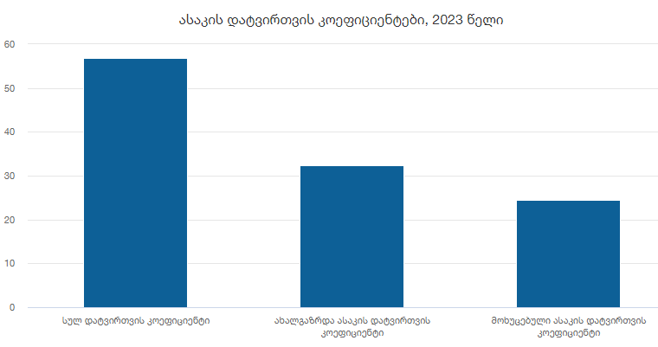
ამასთან აღსანიშნავია, რომ ახალგაზრდებით დატვირთვის კოეფიციენტი ყოველთვის მეტია, ვიდრე მოხუცებულებით დატვირთვის მაჩვენებელი (რადგანაც ახალგაზრდულ ასაკში, სქესთა მეორეული თანაფარდობის გამო, როგორც წესი, ჭარბობენ ვაჟები, ხოლო საპენსიო ასაკის ადამიანებში კი ─ ქალები (მოკვდაობის დაბალი დონისა და მოსალოდნელი სიცოცხლის საშუალო ხანგრძლივობის უფრო მაღალი დონის გამო). თავის მხრივ, ახალგაზრდებით დატვირთვის კოეფიციენტში უფრო მეტად ვაჟების წილი აღემატება ქალებისას, ხოლო მოხუცებულებით დატვირთვის მაჩვენებელში კი პირიქით ─ ქალების წილი აღემატება ვაჟებისას.
საანალიზო პერიოდის განმავლობაში საქართველოში საგრძნობლად დაიკლო შობადობის დონემ, რის საილუსტრაციოდაც 7 გრაფიკზე მოგვაქვს ცოცხლად დაბადებულთა რიცხოვნობის დინამიკა.

გრაფიკი N7: ცოცხლად დაბადებულთა რიცხოვნობა
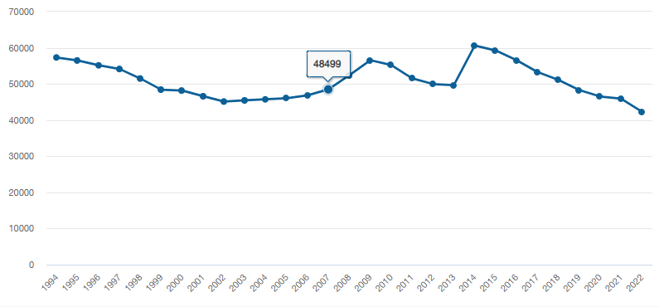

1994 წლიდან 2022 წლამდე პერიოდში ცოცხლად დაბადებულთა რაოდენობა 57 311-დან 42 319-მდე შემცირდა, ხოლო შობადობის ზოგადი კოეფიციენტის სიდიდე კი 11,9‰-დან 11,4‰-მდე შემცირდა (იხ. გრაფიკი 8¹). შობადობის აბსოლუტური და შეფარდებითი მაჩვენებლების ასეთი საპირისპირო მიმართულებით ცვლილება იმითაა განპირობებული, რომ უარყოფითი მიგრაციული სალდოს წყალობით საანალიზო პერიოდში, ცოცხლად დაბადებულთა აბსოლუტური რაოდენობის შემცირებასთან შედარებით, უფრო მეტად დაიკლო საქართველოს მოსახლეობის საშუალო წლიურმა ოდენობამ, ანუ თავი იჩინა ზემოთ აღნიშნული დეპოპულაციური პროცესის ნეგატიურმა გავლენამ და შექმნა მოჩვენებითი წარმოდგენა, თითქოს შობადობის მაჩვენებლები პოზიტიურად იცვლება. სინამდვილეში, ამგვარი ცვლილება კიდევ ერთხელ მიანიშნებს ზოგადი კოეფიციენტის არასაიმედო ანალიტიკურ შესაძლებლობაზე და ამიტომ, მათი გაანალიზების საფუძველზე დასკვნები უაღრესად ფრთხილად უნდა გავაკეთოთ.

გრაფიკი N8: შობადობის ზოგადი კოეფიციენტი, ‰
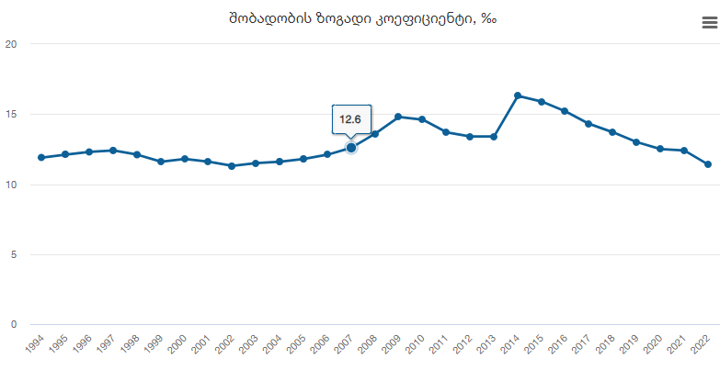

შობადობის დამახასიათებელ მაჩვენებლებს შორის ყურადღებას იმსახურებს სქესთა მეორეული თანაფარდობის ცვლილება, რომლის დინამიკაც (იხ. გრაფიკი 9¹) იმაზე მეტყველებს, რომ ეს მაჩვენებელი თითქმის უმნიშვნელოდ იცვლებოდა და ბუნებრივია მომავალში დიდ გავლენას ვერ მოახდენს როგორც მთლიანად ქვეყნის მოსახლეობის სქესობრივ-ასაკობრივ შემადგენლობაზე, ისე მოსახლეობის გამრავლების რეჟიმზეც. თუმცა, შობადობის საერთო დონის ცვლილებაზე შეიძლება გავლენა მოახდინოს ცოცხლად დაბადებულთა რიცხოვნობის დედის ასაკის მიხედვით განაწილებამ.

გრაფიკი N9: სქესთა რაოდენობრივი თანაფარდობა დაბადებისას
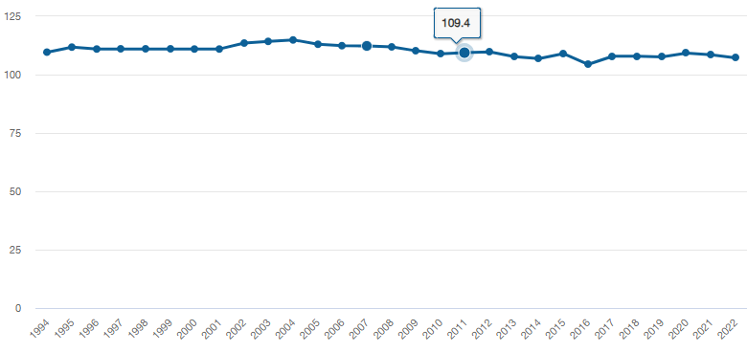
მე-10 გრაფიკიდან ნათლად ჩანს, რომ ბოლო 28 წლის განმავლობაში საქართველოში საგრძნობლად შემცირდა 20 წლამდე ასაკის ქალების მიერ გაჩენილი ბავშვების რიცხვი და გაიზარდა 30 წელს გადაცილებულ ქალთა მიერ გაჩენილი ბავშვების რაოდენობა, ანუ მოიმატა გვიანმა მშობიარობებმა. ეს გარემოება, რა თქმა უნდა, იმის ერთ-ერთი მთავარი მიზეზიცაა, რომ მცირდება შობადობის დონე.

გრაფიკი N10: ცოცხლად დაბადებულთა რიცხოვნობა დედის ასაკის მიხედვით
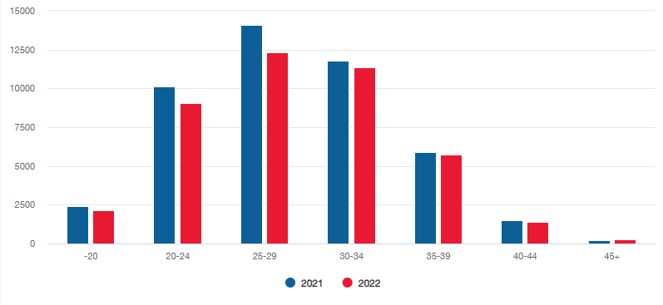
საქართველოში შობადობის დონის შემცირების ერთ-ერთი მთავარი მიზეზი სტრუქტურული ფაქტორია. დღეისათვის და უახლოეს მომავალში ფერტილურ ასაკში შედის 1990-1999 წლებში დაბადებულ გოგონათა შედარებით მცირერიცხოვანი კონტინგენტი, რაც კიდევ უფრო გაამწვავებს ისედაც მძიმე დემოლოგიურ ვითარებას (იხ. ცხრილი N1).²
ცხრილი N1
საქართველოში დაბადებული გოგონების რაოდენობა
ათწლეულების მიხედვით 1960-2009 წლებში

წლები | დაბადებული გოგონების რაოდენობა
1960-1969 | 466 622
1970-1979 | 433 361
1980-1989 | 454 960
1990-1999 | 306 395
2000-2009 | 236 681

როგორც ცნობილია, დაბადებულ ბავშვთა შორის, ტრადიციულად, თითქმის ყველგან და ყოველთვის ჭარბობენ პირველი რიგითობის ბავშვები ანუ პირმშოები, მაგრამ 2018 წლის მონაცემებით, საქართველოში ეს კანონზომიერება დაირღვა და მეორე რიგითობის გაჩენილ ბავშვთა რიცხვმა (19 511) 149-ით გადააჭარბა პირმშოების ოდენობას (19 362). ეს აშკარად არაორდინალური შემთხვევა ძალიან ძნელი ასახსნელია. ამას შეიძლება რამდენიმე მნიშვნელოვანი მიზეზი ჰქონდეს. პირველ რიგში, ვფიქრობთ, ეს მიზეზი შეიძლება ვეძებოთ იმაში, რომ მთელს მსოფლიოში მკვეთრად შეიცვალა ოჯახის დაგეგმვის პოლიტიკაზე მოქმედი ფაქტორები. ეს გამოიწვია რა თქმა უნდა, შრომის ხასიათის მკვეთრმა ცვლილებებმა, მზარდმა ინდუსტრიალიზაციამ, ეკონომიკურმა და სოციალურმა ცვლილებებმა. ქალის როლისა და სოციალური აქტივობის მკვეთრმა ზრდამ, განათლების გაცილებით უფრო ფართოდ მიღების შესაძლებლობებმა და აუცილებლობამ. სამწუხაროდ, ყოველივე ამის, მთლიანობაში უაღრესად პოზიტიური ცვლილებების დემოლოგიური შედეგები გარკვეულად უარყოფითი იყო. ამას ემატება ურბანიზაციის უაღრესად აქტიური პროცესები, ურბანული სივრცის ზრდის ხარჯზე სოფლების დაცლა, მკვეთრად მზარდი მიგრაციული პროცესები და სხვა. ყოველივე ამან კი შობადობის მკვეთრი კლება გამოიწვია, რაც მსოფლიოს განვითარებული ქვეყნების დიდ უმრავლესობაში აქტიური დეპოპულაციური პროცესების საფუძველი გახდა. შობადობის შემცირებაზე ასევე დიდად მოქმედებს ცვლილებები საქართველოს მოსახლეობის ქორწინებით სტრუქტურაში. მაგალითად, თუ საქსტატის მონაცემებით³ 1959-2002 წლებში ქორწინებაში იმყოფებოდა 15 წელზე უფროსი მამაკაცების 70%, ხოლო ქალების 60%, 2002 წელს ქორწინებაში იმყოფებოდა მამაკაცების 64%, ხოლო ქალების 56,8%. მნიშვნელოვნად გაიზარდა ასევე ქორწინებაში შესვლის ასაკიც. თანაც, როგორც მამაკაცების, ასევე ქალებისათვის. საქსტატის მონაცემებით³, თუ დაქორწინებულ ქალთა საშუალო ასაკი 2002 წელს 25.5 იყო, 2014 წლისათვის ის 28-მდე გაიზარდა, ხოლო 2020 წლის მონაცემებით ის უკვე 29.6 წელია. მამაკაცების საშუალო ასაკი 2002 წელს 29.1 იყო, 2014 წელს უკვე 31.3, ხოლო 2020 წლის მონაცემების თანახმად, 32.4 წლამდეა გაზრდილი.
მე-20 საუკუნის მეორე ნახევრიდან საქართველოში აშკარად შეიმჩნევა მცირეშვილიანობის ტენდენცია. საქსტატის მონაცემებით, თუ 1960 წელს მესამე და მეტი ბავშვის დაბადების წილი დაბადებულთა მთელი რაოდენობის 36.5% შეადგენდა, 2009 წელს ეს მაჩვენებელი 13.6%-მდე ჩამოვიდა. ამდენად, უაღრესად მნიშვნელოვანია საქართველოში მრავალშვილიანობის სტიმულირებისათვის გატარდეს აქტიური დემოლოგიური პოლიტიკა. სამწუხაროდ, 2006 წელს საქართველოს კანონმდებლობაში ტერმინი „მრავალშვილიანიც“ კი გაუქმდა. ეს ტერმინი ოფიციალურად აღდგა 2018 წელს მთავრობის დადგენილებით და დადგინდა, რომ მრავალშვილიანის სტატუსი მშობლებს ენიჭებათ იმ შემთხვევაში, თუ ოჯახში არის 4 და მეტი 18 წლის ასაკამდე შვილი ან ნაშვილები. მიუხედავად ამისა, შესაბამისი დემოლოგიური პოლიტიკა სათანადოდ არ ტარდება. სამწუხაროდ, სათანადოდ ჯერ კიდევ არ არის გამიჯნული მრავალშვილიანის სტატუსი და სოციალურად დაუცველის სტატუსი, რაც რეალურ პრაქტიკაში ჯერ კიდევ სერიოზულ პრობლემებს ქმნის. ამას ადასტურებს ამ თვალსაზრისით ჩატარებული სოციოლოგიური კვლევებიც. აუცილებელია გავითვალისწინოთ ამ მხრივ არსებული პრაქტიკა, როგორც ევროპის განვითარებულ ქვეყნებში, ასევე აღმოსავლეთის განვითარებად ქვეყნებშიც. უფრო მეტიც, მრავალშვილიანობის სტიმულირებისათვის დემოლოგიური პოლიტიკის წარმოებისას აუცილებელია არა მხოლოდ სხვადასხვა ქვეყნების თავისებურებების გათვალისწინება, არამედ გათვალისწინებული უნდა იყოს საქართველოს სხვადასხვა დემორეგიონების დემოლოგიური მდგომარეობა და თავისებურებები.
მეორე რიგში, ამის მიზეზი შეიძლება იყოს ქორწინებათა რაოდენობის შემცირება (რადგანაც, ძირითადად, როგორც წესი, პირმშოები უჩნდებათ ახალდაქორწინებულებს, ანუ დაქორწინებიდან დაახლოებით პირველი 5 წლის განმავლობაში), რასაც ადასტურებს კიდეც N2¹ ცხრილში მოტანილი მონაცემები 2013-2020 წლების განმავლობაში რეგისტრირებულ ქორწინებათა რაოდენობის თითქმის განუხრელი კლების შესახებ.
ცხრილი 2¹
ქორწინებათა რიცხვის დინამიკა საქართველოში 1994-2022 წლებში
წლები | ქორწინებათა რიცხვი | წლები | ქორწინებათა რიცხვი
1994 | 21908 | 2009 | 31 752
1995 | 21 481 | 2010 | 34 675
1996 | 19 253 | 2011 | 30 863
1997 | 17 099 | 2012 | 30 412
1998 | 15 343 | 2013 | 34 693
1999 | 13 845 | 2014 | 31 526
2000 | 12 870 | 2015 | 29 157
2001 | 13 336 | 2016 | 25 101
2002 | 12 535 | 2017 | 23 684
2003 | 12 696 | 2018 | 23 202
2004 | 14 866 | 2019 | 23 285
2005 | 18 012 | 2020 | 16 359
2006 | 21 845 | 2021 | 23 255
2007 | 24 891 | 2022 | 26 048
2008 | 31 414

გარდა ამისა, პირმშოების რაოდენობასთან შედარებით, მეორე რიგითობის ბავშვების სიჭარბე შეიძლება გამოეწვია იმ ფაქტსაც, რომ 2014 წლის 1 ივნისის შემდგომ პერიოდში, საქართველოს მძიმე დემოგრაფიული მდგომარეობის (დეპოპულაციურ) 6 რეგიონში ფინანსურად სტიმულირდება მესამე რიგითობის ბავშვების გაჩენა, რაც მძიმე ეკონომიკური ვითარების გამო, შესაძლოა გამხდარიყო ჯერ მეორე, ხოლო მოგვიანებით კი მესამე ბავშვის გაჩენის სტიმულიც⁶.
მოსახლეობის საყოველთაო აღწერების მონაცემების ანალიზი ნათლად აჩვენებს, რომ თანამედროვე საქართველოს ქორწინებითი სტრუქტურა დემოლოგიური თვალსაზრისით აშკარად უარყოფითი ტენდენციით ხასიათდება. თუმცა უნდა აღვნიშნოთ, რომ ქორწინებითი სტრუქტურა საქართველოში რთულ ცვლილებებს განიცდიდა უკვე 1926 წელს ჩატარებული საყოველთაო აღწერის შედეგებით. 1926 წლის აღწერით, დაქორწინებული იყო ქალების 63.4%, ხოლო ვაჟების 63.3%. 1959 წლის აღწერიდან 1989 წლის აღწერამდე პერიოდში, 20 წლამდე ასაკის ქალებისა და მამაკაცების ქორწინებათა რაოდენობა ძალიან ნელი ტემპით, მაგრამ მაინც იმატებდა. ამ პერიოდშივე იმატებდა 20-24 წლის ასაკში მყოფთა ქორწინებათა რიცხვიც, განსაკუთრებით ─ ქალებში.
25-29 წლის დაქორწინებული მამაკაცების მაქსიმალური რაოდენობა დაფიქსირდა 1959 წელს, ხოლო 1970 წლიდან ის კლებას იწყებს. ქალებში, ყველაზე მეტი დაქორწინებული ქალი დაფიქსირდა1970 წლის აღწერაში⁴, ხოლო ამის შემდეგ კაცების მსგავსად, ისიც იკლებს.ასე ხდება უფრო ზემო ასაკობრივ კატეგორიებშიც.
საბოლოო ჯამში შეგვიძლია აღვნიშნოთ, რომ 1954 წლის აღწერიდან 1989 წლის აღწერამდე პერიოდში, მხოლოდ 20 წლამდე, 20-24 და 25-29 წლის ასაკობრივ კატეგორიებში დაქორწინებული ქალი უფრო მეტია, ვიდრე მამაკაცი. დანარჩენ ასაკობრივ კატეგორიებში კი პირიქით, მამაკაცები ჭარბობენ ქალებს.
2002 წლის პირველი ეროვნული საყოველთაო აღწერის შედეგების მიხედვით, 15 წლის და ზემოთ მყოფი ასაკობრივი კატეგორიის ადამიანთა რაოდენობა, რომლებიც იმყოფებიან რეგისტრირებულ ქორწინებაში 2087980 შეადგენდა და ის წინა, 1989 წლის აღწერასთან შედარებით 501785 ადამიანით შემცირდა. მათ შორის, მამაკაცები 1028247, ხოლო ქალები 1059733 იყვნენ. ამასთან, რეგისტრირებულ ქორწინებაში მყოფი მამაკაცების რაოდენობა ქალაქში უფრო მეტია, ვიდრე სოფლად. ასევეა ქალებშიც. ამის ერთ-ერთი ძირითადი მიზეზი უთუოდ ისიც არის, რომ საქალაქო დასახლებაში უფრო მეტი ადამიანი ცხოვრობს, ვიდრე სოფლად.
საქსტატის მონაცემების მიხედვით, დაქორწინებულთა საშუალო ასაკი ყოველ წელიწადს განუხრელად იზრდება. თუ 1994 წელს ეს ასაკი მამაკაცებში 27.7 იყო, ხოლო ქალებში 23.8, უკვე 2020 წელს ეს ასაკი, შესაბამისად, 32.4 და 29.6 გახდა⁵ .
2014 წლის აღწერის შედეგების მიხედვით, 2014 წელს დაფიქსირდა 31526 რეგისტრირებული ქორწინება. ეს წინა, 2013 წელთან შედარებით, თითქმის 3 ათასით შემცირდა.
ამრიგად, შეგვიძლია გავაკეთოთ დასკვნა, რომ მე-20 საუკუნის დასაწყისში, კერძოდ, 1926 წელს დაქორწინებულთა ყველაზე დიდი რაოდენობა მამაკაცებში 25-29 წლის ასაკობრივ კატეგორიაზე მოდიოდა, ხოლო ქალებში ─ 20-39 წლის კატეგორიაზე. შემდგომი აღწერების მონაცემებით, დაქორწინებულთა საშუალო ასაკი განუხრელად იმატებს. მე-20 საუკუნის შუა პერიოდში დაქორწინებული მამაკაცების რაოდენობა 30-49 წლამდე კატეგორიაზე მოდის, ხოლო ქალების ─ 25-34 წლის ასაკობრივ კატეგორიაზე.
როგორც აღვნიშნეთ, პოსტსაბჭოთა პერიოდში, საქართველოს დემოგრაფიული მდგომარეობის გაუარესებაში ძალიან დიდი მნიშვნელობა ჰქონდა შრომითი ემიგრაციის არნახულ მასშტაბებს (მაგალითად, 1994 წელს ─ 1943 634). მართალია, წინა პერიოდთან შედარებით, 2012 წლიდან მიგრაციის უარყოფითი სალდო საგრძნობლად შემცირდა, მაგრამ იშვიათი გამონაკლისის გარდა (2014, 2015, 2017, 2021 წწ), მისი სიდიდე მაინც აღემატებოდა ბუნებრივი მატების ოდენობას და იწვევდა მოსახლეობის რიცხოვნობის შემცირებას (იხ. ცხრილი N3) ¹.
ცხრილი N3
მიგრაციის სალდოსა და ბუნებრივი მატების დინამიკა
საქართველოში 2012-2022 წლებში (კაცი)
წლები | 2012 | 2013 | 2014 | 2015 | 2016 | 2017 | 2018 | 2019 | 2020 | 2021 | 2022
მიგრაციის სალდო | -21521 | -2606 | -6620 | -3408 | -8060 | -2212 | -10783 | -8243 | 157732 | -25966 | 54509
ბუნებრივი მატება | 622 | 1-93 | 11548 | 10128 | 5798 | 5471 | 4637 | 1637 | -4017 | -13960 | -6799

შობადობასთან ერთად, სახელმწიფომ ყურადღება უნდა მიაქციოს ემიგრაციულ პროცესებსაც, რომლის მასშტაბებიც საკმაოდ შთამბეჭდავია და მცირერიცხოვანი დადებითი ბუნებრივი მატებისასაც კი, ─ რომლის მიღწევაც, თავისთავად, არც თუ ისე მარტივი ამოცანაა, ─ მოსახლეობის რიცხოვნობას შემცირებით ემუქრება. ამ საკითხზე ყურადღების გამახვილება ჩვენ აქტუალურად გვეჩვენება, რადგან ემიგრაციამ (მათ შორის თუნდაც შრომითმა), საკმაოდ ფართო მასშტაბები მიიღო და აშკარა პრობლემები შეუქმნა საქართველოს დემოლოგიურ განვითარებას. ამ ფონზე მნიშვნელოვნად მიგვაჩნია, რომ სახელმწიფომ საკანონმდებლო წესით არა მარტო იმიგრაციული პრეოცესების დარეგულირებაზე უნდა იზრუნოს, არამედ დემოლოგიური კატასტროფის თავიდან ასაცილებლად სათანადო რეგულაციები შემოიღოს ემიგრანტების მიმართაც, რადგანაც, როგორც პრაქტიკა აჩვენებს ემიგრანტების მნიშვნელოვანი ნაწილი წასულია არა მხოლოდ თავის გადასარჩენად და აქ დარჩენილი ოჯახის წევრების შესანახად, არამედ სხვა მიზეზების გამოც.
დამოუკიდებლობის მოპოვების შემდეგ, საქართველო თანდათან გახდა გლობალური მიგრაციული სისტემის ნაწილი. მას მერე განვლილ პერიოდში დიდად შეიცვალა საქართველოდან ემიგრაციის მახასიათებლები: მოცულობა, მიმართულებები და სხვ. უდავოა, რომ ბოლო ათწლეულებში მიგრაციული პროცესების ასეთი ცვლილებები გამოიწვია სამმა ძირითადმა მიზეზმა: 1. ომებმა და გარედან ორგანიზებულმა ეთნოპოლიტიკურმა კონფლიქტებმა და ომებმა. 2. ქვეყნის ეთნიკურ უმცირესობათა მასობრივმა გადინებამ უმეტეს შემთხვევაში სამშობლოში დაბრუნების მიზნით და 3. მოსახლეობის ნაწილის სხვა ქვეყნებში საცხოვრებლად დროებით ან მუდმივად გამგზავრებამ, ეკონომიკური და სოციალური პირობების გასაუმჯობესებლად.
თუმცა, არ შეიძლება ითქვას, რომ საქართველოში გარე მიგრაციული პროცესები მხოლოდ საბჭოთა კავშირის დაშლის შემდეგ დაიწყო. მიგრაციის უარყოფითი სალდო უკვე 1960-იანი წლებიდან აღინიშნება. 1960-1991 წლებში მოსახლეობის მიგრაციის უარყოფითი სალდო 5-დან 25 ათასამდე მერყეობდა და ჯამში, აღნიშნულ წლებში 421.1 ათასის ტოლი იყო. ე.ი. მხოლოდ გარემიგრაციული პროცესების შედეგად ქვეყნის მოსახლეობას აღნიშნულ პერიოდში დაახლოებით 500 000 ადამიანი დააკლდა⁵. მოსახლეობის მიგრაციის უარყოფითმა სალდომ განსაკუთრებით 1992-96 წლებში მიაღწია მაქსიმუმს (მაგალითად, 1994 წელს მან ისტორიულ მაქსიმუმს ─ 143 ათასს მიაღწია). მთლიანად, აღნიშნულ პერიოდში უარყოფითი სალდოს ჯამური მაჩვენებელი 700 ათასზე მეტი საქართველოს მოქალაქე იყო. საქსტატის მონაცემებით, 1995-2000 წლებში მიგრაციის უარყოფითი სალდოს 70% რუსეთის ფედერაციაზე მოდიოდა. 1995-96 წლებში ეს მაჩვენებელი 72% იყო. შემდეგ კი, 1997-2000 წლებში იგი მნიშვნელოვნად შემცირდა ─ 57%-მდე. მნიშვნელოვანი დასკვნების გაკეთების საშუალებას გვაძლევს 2002 და 2014 წლებში საქართველოში ჩატარებული საყოველთაო აღწერების მონაცემები. მაგალითად, საინტერესოა, რომ 2014 წლის მოსახლეობის საყოველთაო აღწერის მიხედვით, საქართველოში მცხოვრებმა 66230 ადამიანმა განაცხადა, რომ ისინი საქართველოს საზღვრებს გარეთ დაიბადნენ. მათგან თითქმის ნახევარი დაიბადა რუსეთში. აღწერამ აჩვენა ისიც, რომ ამ პერიოდში იმიგრაციის პროცესიც დაიწყო. 2014 წლის აღწერის მიხედვით, იმიგრანტთა უმრავლესობას თავის სამშობლოში დაბრუნებული ემიგრანტები წარმოადგენდნენ (სულ დაახლოებით 138 ათასი, აქედან 80 ათასამდე მამაკაცი, ხოლო 58 ათასამდე ქალი). მათ შორის, უმრავლესობას, ისევ რუსეთიდან ჩამოსულები შეადგენდნენ. მცირდება სხვა ქვეყნებში თავშესაფრის მაძიებელთა რაოდენობაც. Eurostat-ის მონაცემებით, ევროკავშირის წევრ სახელმწიფოებში შეინიშნება თავშესაფრის მაძიებელ საქართველოს მოქალაქეთა განცხადებების შემცირების გამოკვეთილი ტენდენცია. 2014 წლიდან საქართველო აღარ შედის იმ 15 ქვეყნის სიაში, საიდანაც ევროკავშირის ქვეყნებში ყველაზე მეტი თავშესაფრის მაძიებელი ჩადის.
საინტერესოა და ვფიქრობთ, აუცილებლად კარგად უნდა გავიაზროთ თითქმის ბოლო ორი ათწლეულის განმავლობაში საქართველოში მიმდინარე მოსახლეობის იმიგრაციული პროცესები. მათ შორის სხვა ქვეყნების მოქალაქეთა იმიგრაციული პროცესები. ცნობილია, რომ 2000-იანი წლების შუა პერიოდიდან 2014 წლამდე, სპეციალური კანონის მიღებამდე მოქმედებდა ისეთი სავიზო რეჟიმი, რომლის მიხედვითაც 100-ზე მეტი ქვეყნის მოქალაქეს შეეძლო შემოსულიყო, ეცხოვრა, ემუშავა, ესწავლა ყოველგვარი ვიზის ან ბინადრობის ნებართვის გარეშე.
მნიშვნელოვანია ცალკე იქნეს გაანალიზებული საქართველოში შრომითი იმიგრანტების მოძრაობასთან დაკავშირებული საკითხები. მიუხედავად იმისა, რომ საქართველოში შრომის ბაზრის მობილობას არეგულირებს კანონი „შრომითი მიგრაციის შესახებ“ და სხვა კანონქვემდებარე აქტები, ამ სფეროში ბევრი სერიოზული პრობლემა დაგროვდა.
ყველა ზემოთ აღნიშნული პრობლემის შესწავლა, გაანალიზება და შესაბამისი სახელმწიფო ზომების გატარება გადაუდებელ აუცილებლობად მიგვაჩნია იმიტომ, რომ გლობალურ მიგრაციულ სისტემაში ჩართვის შედეგად, საქართველოში მკვეთრად შეიცვალა და მომავალში ალბათ კიდვ უფრო შეიცვლება საერთაშორისო და შიდა მობილურობის ფორმები. აქამდე თუ საქართველო ემიგრაციისა და სატრანზიტო სტატუსის ქვეყანა იყო, დღეს მან უკვე აშკარად შეიძინა ე.წ. დანიშნულების ქვეყნის სტატუსიც.
ყოველივე ზემოთქმულიდან გამომდინარე, მიზანშეწონილად მიგვაჩნია თანამედროვე საქართველოს დემოლოგიური მდგომარეობის გაუმჯობესების მიზნით, საქართველოს პარლამენტის მიერ 2016 წელს მიღებულ ქვეყნის დემოლოგიური უსაფრთხოების კონცეფციაზე დაყრდნობით, დამუშავდეს მოსახლეობის რიცხოვნობის სტაბილიზაციის გრძელვადიანი პროგრამა.⁷
ქვეყანაში არსებული მძიმე ეკონომიკური მდგომარეობის გათვალისწინებით, ასევე მიზანშეწონილად მიგვაჩნია კიდევ უფრო გაფართოვდეს ბავშთა შობის მატერიალური სტიმულირების ღონისძიებები.
მოსახლეობის საერთო მატების უზრუნველყოფისთვის, ბუნებრივი მატების ზრდასთან ერთად, სტრატეგიულ ამოცანად მიგვაჩნია შრომითი ემიგრაციის ძალიან მაღალი დონის რეგულირება და ისეთი კანონმდებლობის შემუშავება, რომელიც დემოგრაფიული კატასტროფის თავიდან ასაცილებლად, სათანადო რეგულაციების შემოღებას გაითვალისწინებს.
სახელმწიფო ვალდებულია დროულად გაატაროს სათანადო დემოლოგიური პოლიტიკა ემიგრაციის გამომწვევი მიზეზების აღმოსაფხვრელად.

გამოყენებული ლიტერატურა
ა. თოთაძე. „დემოგრაფიული ვითარება საქართველოში და დემოგრაფიული განვითარების პროგრამა“. თბილისი, 2016 წ.
გ. წულაძე, ნ. მაღლაფერიძე, ა. ვადაჭკორია. „საქართველოს დემოგრაფიული განვითარება“. თბილისი, 2002 წ.
გ. წულაძე და სხვ. „საქართველოს დემოგრაფიული განვითარება გუშინ, დღეს, ხვალ“. თბილისი, 2008 წ.
ა. სახვაძე. „ქვრივები საქართველოში (სტატისტიკურ-დემოგრაფიული გამოკვლევა)“. თბილისი, 2014 წ.
ვ. ლორთქიფანიძე. „დემოლოგია“. 2018 წ.

