2021 local elections in Georgia: geographic patterns of voter turnout

Abstract
The paper outlines the main geographic features of voter turnout in Georgia’s 2021 local elections. The research findings are primarely based on the analysis of official data of 2021 municipal (local) elections. Traditionally, Georgian public had been demonstrating lack of interest towards municipal elections and resultant low voter turnout; however, the latest elections marked considerable difference, as it was preceded by acute political confrontation. For the first time in Georgia’s history, municipal elections involved more than half of total electorate (52%). The research confirms that voter turnout in Georgia is high when high political odds are at stake. Voter turnout is higher in rural, especially smaller settlements. Factor of social solidarity conditions not only high turnout but also high number of political parties in local councils (Sakrebulos).

Keywords: local elections, Georgia, voter turnout, voting, electoral geography.

Authors:
Giorgi Gogsadze,
Department of Human Geography, Faculty of Social and Political Sciences, Ivane Javakhishvili Tbilisi State University, address: 8, Ilia Chavchavadze avenue, Tbilisi Georgia; e-mail: giorgi.gogsadze@tsu.ge ORCID: https://orcid.org/0000-0003-0618-5299

Tamar Dolbaia,
Department of Human Geography, Faculty of Social and Political Sciences, Ivane Javakhishvili Tbilisi State University, address: 8, Ilia Chavchavadze avenue, Tbilisi Georgia; e-mail: tamar.dolbaia@tsu.ge ORCID: https://orcid.org/0000-0002-4902-800X

Vladimer Chkhaidze,
Department of Human Geography, Faculty of Social and Political Sciences, Ivane Javakhishvili Tbilisi State University, address: 8, Ilia Chavchavadze avenue, Tbilisi Georgia; e-mail: vladimer.chkhaidze@tsu.ge ORCID: https://orcid.org/0000-0001-7605-1398
Introduction

Rivalry between the two main political parties, the Georgian Dream (GD) and the United National Movement (UNM), that predominates Georgia’s political scene over a decade, has made the country “a hostage of polarization” (Gegeshidze & De Waal, 2021). 2020 parliamentary elections could not end the crisis either. Although OSCE office for Democratic Institutions and Human Rights (ODHIR) Election Observation Mission in overall positively assessed 2020 parliamentary elections (OSCE-ODHIR, 2020), majority of opposition parties boycotted election results and refused to take MP mandates.
As a result, to EU’s moderation efforts to discharge tensed political situation, the ruling party and part of the opposition signed the agreement “A Way Ahead for Georgia” (2021). The signatories committed to stop malpractice of politically motivated prosecution and implement significant judicial and administrative reforms, which would ensure stable development of the country. In addition, the fifth article of the agreement mandated the ruling GD party to hold a snap parliamentary election in 2022 should it fail to garner at least 43% of vote through party list system in municipal elections scheduled for 2021 (European Council President Makes New Proposal…, 2021). Although the main opposition party – UNM did not sign the agreement and the ruling party withdrew itself from it three months after signing, the municipal elections informally attained importance of a referendum. Several days before elections, Michael Saakashvili, Georgia’s former president and informal leader of the UNM, illegally arrived in the country. On the eve of the elections the police detained him as far as there were criminal charges against him, resulting in further increase of tensions. Consequently, Georgian electorate attached big importance to 2021 elections that was demonstrated in a record high turnout for municipal vote.
2021 elections of local self-government bodies were conducted in 64 municipalities (including five self-governing cities and 59 self-governing communities) on October 2, and the follow-up second round (wherever needed) on October 30. The elections were not held in Abkhazia and Tskhinvali Region (South Ossetia), which are occupied by Russia. Each municipality (including self-governing cities) elected: a) representative council – Sakrebulo, and b) Mayor - representing executive power of self-governing city or self-governing community (Organic Law of Georgia . . ., 2020).
In June, 2021, three months before the elections, the Parliament of Georgia approved important amendments to “the Organic Law of Georgia: The Election Code of Georgia”. Number of Tbilisi City Council (i.e., Sakrebulo) members was set at 50, and for other self-governing cities at 35. In case of self-governing communities, the number varies from 18 to 45. Those changes also applied the electoral system, particularly, the ratio between Sakrebulo members elected by party lists and single mandate constituencies. In Tbilisi Council, instead of the equal distribution of seats (25 proportional, 25 majoritarian), 80% of the seats were determined by party lists (40 seats). The same proportion applied to Sakrebulos of self-governing cities, where previously only 60% of the seats were allocated under the proportional system. The share of proportional (i.e., party list) seats in Sakrebulos of self-governing communities also increased to 2/3 of the total membership. Previously, the share of local council members elected by a party list in self-governing communities averaged 49%. The amendments also reduced the election threshold for Sakrebulo elections. Prior to the change, the law had set 4% threshold for proportional vote. The amended legislation reduced the thresholds: 2,5% for the Tbilisi, and – 3% for all other municipalities. Reducing the barrier level allowed more political parties to enter the local representative body, however, due to the small number of seats to be distributed in the constituency, the political party crossing the threshold with the minimum number of votes would win only one seat in municipality or city council. Majoritarian (i.e., single seat) system aloud a candidate to win in the first round in case of gaining more votes than others, but not less than 40% of votes cast. For being elected as a mayor, a candidate needed over 50% of all votes from ballot box. The second round were announced in those constituencies where the above requirements were not met (Parliament Amends Election Code, 2021).
The last municipal elections did not count as successful for the ruling party, because voters support to it decreased as compared to both: 2017 municipal and 2020 parliamentary elections (see figure 1). Compared to 2017 local self-government elections, ruling party GD received less votes in 65 municipalities out of 73. Moreover, in 28 municipalities support to GD reduced by10 percent points. GD received less votes in 2021 local elections than in 2017 municipal or 2020 parliamentary elections. Support to the party is lower in the overwhelming majority of municipalities, including large cities. The ruling party failed to gain majority of votes in any of the urban centers (15,000 inhabitants and more). Overall success of the GD falls on the account of the rural electorate’s support.
Figure 1
2021 Local Elections in Georgia: Results by Party Lists
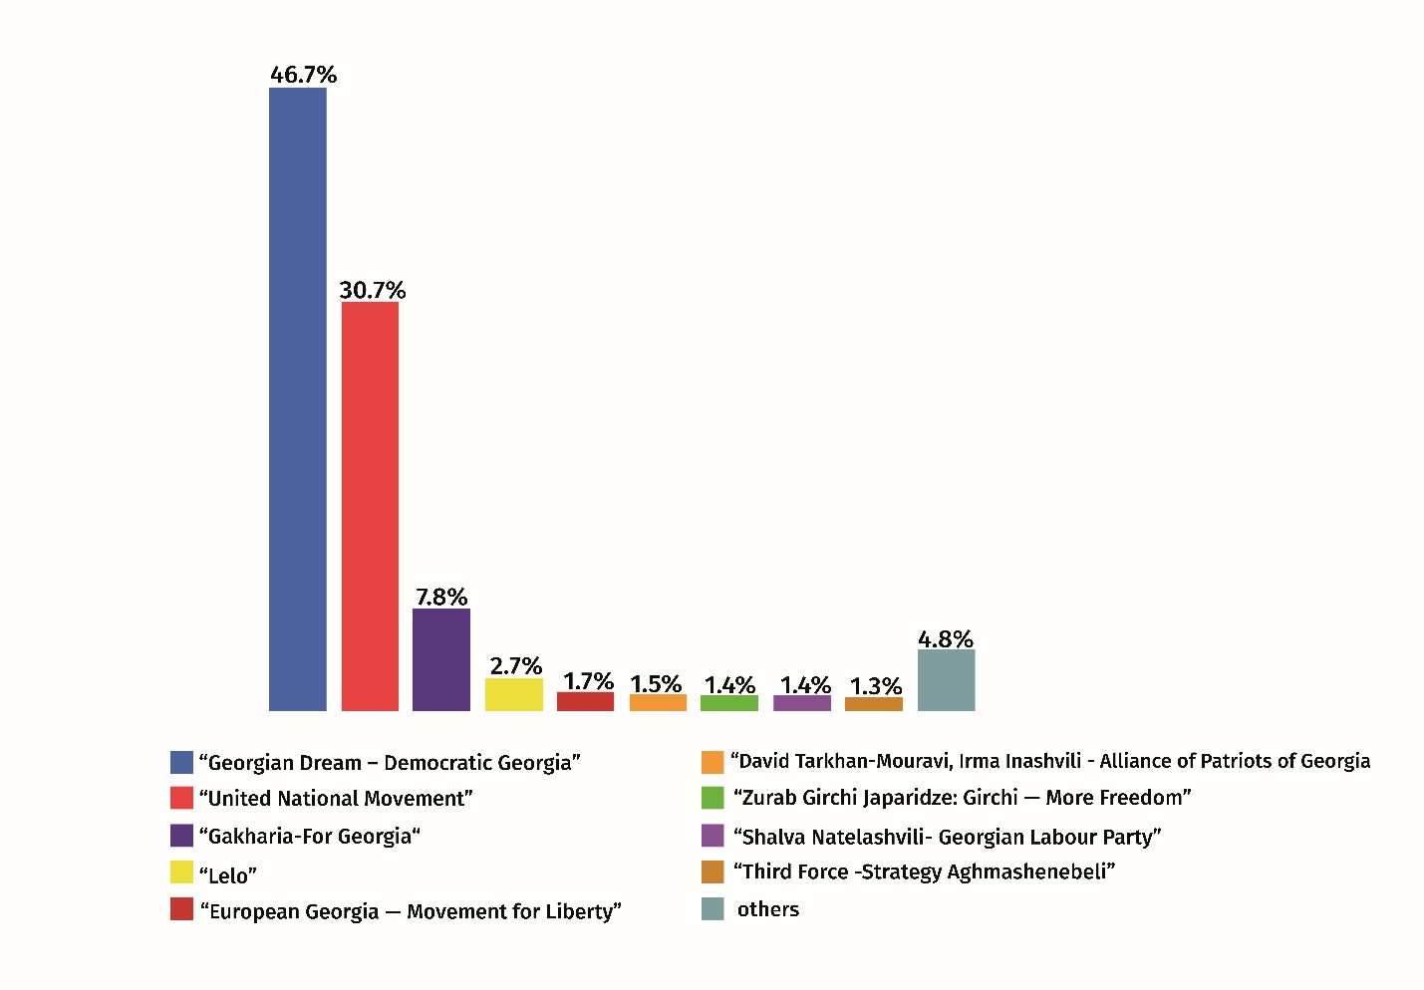
Own work based on data provided by the following source: Results, Municipal Elections (2021), Central Election Administration. https://archiveresults.cec.gov.ge/results/20211030/#/en-us

Geography of results of 2021 local elections has become rather diverse compared to previous elections, and accordingly, the country’s political landscape has changed. On the one hand, overall support towards two main political powers, GD and UNM has not significantly dropped (together they received around 75% of total votes); on the other, the third force – “For Georgia” party appeared on a political scene. While in 2017 the ruling GD easily won chairmanships in all local councils, support to “For Georgia” party appeared to be decisive in electing a chair in several Sakebulos. In addition, support to small opposition parties, which got seats in the parliament a year ago, considerably diminished.
Municipal (local) elections, in general does not attract much attention of the field scholars. This might be caused by the fact that local elections by rank and importance stand lower than parliamentary or presidential elections (Gendźwiłł & Steyvers, 2021, p.2).
Election geography became a subject of study in Georgia on the eve of the collapse of the Soviet Union. During the recent 15 years the researches have been intensified in this direction (e.g., Sichinava, 2017; Gachechidaze & Gogsadze, 2021). Yet, full scale geographic study of municipal (local) elections has not been conducted in Georgia. Unlike advanced democratic countries, local government and self-government bodies have insignificant influence over a social and economic life of Georgians. This has two reasons. On the one hand, this is a post-communist inertia. With an exception of 2001 Tbilisi local council elections, all other municipal elections were conducted in dull and uncontested environment, with a big advantage of parties in power. On the other hand, local bodies, except in Tbilisi, have very limited financial resources and therefore are not able to implement important changes. The given research is a first attempt to fill a gap in Georgia’s electoral geography that exists in the area of municipal elections.
The paper reveals the main geographic patterns of voter turnout (VT) in 2021 municipal elections in Georgia, through answering to the following questions:
- What made 2021 municipal elections different from previous ones?
- Which factors influence voter turnout of Georgian electorate by geographic regions and municipalities?
- What were the specific geographic patterns of VT in 2021 local elections?

Methods and data
The main method applied to this research employs processing and analysing official data of 2021 municipal elections, as provided by the Election Administration of Georgia. Statistics on migration was obtained from the official site of the National Statistics Office of Georgia. To describe rules of conducting elections and other legal issues, the research refers to Georgian legislation, primarily Election Code of Georgia (Organic Law of Georgia. . ., 2020).
To overview and assess administration of 2021 municipal elections, the research cites reports developed by international organizations and local NGOs, first of all – ODIHR (Democratic Institutions and Human Rights) Election Observation Mission (OSCE – ODIHR, 2021), as well as NDI Georgia (NDI Georgia, 2021), International Society for Fair Elections and Democracy (ISFED, 2021), Georgian Young Lawyers’ Association (GYLA, 2021).
One of the main goals of the paper was to establish theoretical frame of a research and to conduct academic discussion. For this reason, particular attention was placed on the review and critical assessment of various scientific works on election topic.
Georgia administratively is divided into 12 regions (including two autonomous republics Ajara and Abkhazia, and capital city of Tbilisi). Next level of administrative-territorial organization includes 64 municipalities (including 5 self-governed cities). Regional division is used for visualization of voter turnout (see figure 2).
The paper is dedicated to the analysis of the VT. In general, electoral studies employ two approaches in measuring voter turnout: 1) registered turnout – ratio between the number of voters and the number of registered voters, and 2) voting-age-population turnout (a proportion between the number of voters divided by the number of citizens above the legal voting age) (Comsa, 2017, p. 38). To calculate VT, Georgian election authorities traditionally use „registered turnout” approach. Prior to 2006, Georgia’s election administration did not provide country-wide data on local elections, but rather through certain constituencies. Therefore, general statistics on VT for 1991-2001 is not available. The VT figures used in this paper cover the period after 2006.
To create a cartographic model and visualize the research results, it was necessary to find the sources of the needed data (geographical and attributive). For this, an analysis of existing data was carried out in organizations involved in the creation of the necessary geographical and attribute (quantitative) information. In addition, there was one more datum source: National Agency of Public Registry (NAPR). After obtaining the needed information, it was necessary to analyze the received data structures and create a common configuration for further processing. Next, a data storage platform (database) and a compatible geographic information system were selected. Relational Database Management System (RDBMS) PostgreSQL/PostGIS as data storage and Geographical Information System (GIS) QGIS for mapping was chosen. The obtained data were integrated into a designed structure and relevant relationships were created. That made it possible to create a database to obtain the required geodata model within the mapping facilities.
The final cartographic design of the maps was done by Adobe Illustrator. As a result, we received static maps for printed version (for hard copy). However, in case of use of those maps, based on the existing data as web site component, can offer much more flexible possibilities, such as interactive mapping.

Theoretical framework and literature review
In early XX century, French scholar Andre Siegfried pioneered the geographic study of elections. Since then, electoral geography has been dealing with three intertwined subjects - geography, politics and democracy (Kavianirad & Rasouli, 2015, 94), and therefore its theoretical framework covers variety of academic theories, approaches and patterns.
During recent 20-30 years, voter turnout has become rather popular subject of study than voting for the academic circles. There are several factors influencing VT: political, legal-institutional, social-economic, human mobility (migration), demographic, geographic, and cultural. From these factors each has a different effect over the VT of different countries.
The experts of the area agree that VT is high in the countries where participation is mandatory. According to Georgia’s legislation, voting is voluntary civil responsibility, and it can hardly become mandatory in a foreseeable future.
In the new democracies of the Eastern Europe, previously part of Warsaw Pact or Soviet Union (including Baltic states), VT in parliamentary elections demonstrates annual 1% decline starting from 1990 (Comsa, 2017, 31). Exceptions here are Poland and Hungary (International IDEA, 2021).
Part of the scholars (e.g., Inglehart, Catterberg, 2002; Kostadinova, 2003; Kostelka, Blais, 2018) consider that by the end of 1990ies, “post-honeymoon” and “post-communist demobilization” became obvious in Eastern European post-communist countries. This was mainly conditioned by a significant frustration of the electorate, related to less efficient political processes and dishonest actions of political elite (Rose, 1999; Norris, 1999; Katz, 2007; Hanspeter, 2008). Although researches do not clearly explain why VT declined steadily in the following decades.
Another part of scholars (e.g., Bell, 2001; Pacek et al., 2009) consider that populations’ social-economic situation negatively affects VT. There is a controversial approach to this problem. On the one hand, we can assume that unfavorable material conditions of the population promote their mobilization for elections; however, on the other hand, poverty may have counter effect, by causing nihilism towards political processes (e.g, Radcliff, 1992). Significant part of the scholars (e.g, Arcelus & Meltzer, 1975, Blais & Dobrzynska, 1998, Blais, 2000, Kostadinova 2003, Fornos et al., 2004) believe that both factors are valid.
Considerable number of electoral studies shows that there is a clear correlation between high VT and importance of elections (e.g., Downs, 1957; Riker & Ordeshook, 1968; Tullock, 1967). Voters in the new democracies of the Eastern Europe tend to take active part in elections when more is at stake. In 2000’ this concept found an empirical support (e.g., Pacek et al., 2009). Furthermore, contested elections facilitate higher VT (Blais, 2006, 122).
It is also interesting to look into the correlation between the number of participating political subjects and VT. At a first glance, diversity of a political spectrum should offer higher choice. However, according to the majority of empirical studies, correlation between the abundance of political parties and VT is negative (Jackman, 1987, Blais & Carty, 1990, Blais & Dobrzynska, 1998, Radcliff & Davis, 2000, Kostadinova 2003). Latin America is an exception, where high number of political parties contributes to higher VT. (e.g. Fornos et al., 2004).
Part of scholars side with the opinion that VT is high in those countries where proportional electoral system is applied. They believe this is characteristic to highly developed European countries (Blais & Carty 1990, Franklin 1996, Radcliff & Davis 2000). Proportional electoral system is used in the majority of EU countries, more specifically 13 of them, while majoritarian system is used in only two: UK and France. In both, especially in France, VT is much lower than in most of the EU countries. However, EU’s example does not allow us to conclude that VT turnout is higher in the countries with proportional electoral system, than in the countries with mixed electoral system (Italy, Germany, Hungary).
For a long time, scholarly works paid little attention to correlation between migration and VT. In reality, human mobility has a direct effect on the size of population, and respectively that of electorate. Collapse of communist regime entailed population drain from eastern Europe to more developed regions. This large-scale migration conditioned decline of VT in young European democracies in 2000s. (e.g., Comsa, 2017; Wigginton et al., 2019).
Many experts believe that the VT is directly related to a country’s demography. More precisely, VT is higher is small countries, where it is easier to mobilize the electorate (e.g., Jackman, 1987; Stockemer, 2017; Blais et al., 2003; Verba & Nie, 1972; Oliver, 2000). Furthermore, number of researches argue that size and density of population matter more at municipal, rather than national level. Elections in less populated areas are more personalistic (e.g., Blank, 1974).
From social-geographic factors that have effect over VT, we can single out traditional rural-urban “cleavage”: international empirical experience proves that VT is higher in rural areas than in urban (e.g., Henderson & McEwen 2010), especially at subnational level, as far as the voters are more familiar with the candidates running in the elections (e.g., Cancela & Geys, 2016; Geys, 2006).
Is there any correlation between high VT and support to incumbent political power? This issue was highly debated until empirical researches were conducted, which proved that in democratic societies there is no unilaterally positive correlation between these electoral factors (Grofman et al., 1999; Jordan, 2017; Vaishnaw & Guy, 2018).

Results and discussion
In the previous chapter we outlined main factors that influence VT. In this chapter, on the example of Georgia’s municipal elections, we will try to identify electoral-geographic features that are characteristic to VT.
Georgia belongs to the group of post-Soviet countries with hybrid democracy, which are characterized by relatively low VT. This is particularly true about local elections. Several political factors determined low VT in local elections of 2006-2017 (e.g., “post-honeymoon effect”, “post-communist demobilisation”, electorate’s disenchetment with major parties). However, sharp decline in VT of 1990s and the first decade of 2000s was also conditioned by mass emigration. After the last Soviet census, Georgia’s population decreased from 5,5 to 3,7 milion (Geostat, 2022). Considering that natural increase in the given period was positive, we can conclude that reduction of population/electorate was a result of emigration. A mass exodus of the population was caused by two armed ethnopolitical conflicts, civil clashes, economic stagnation, and material hardship. In mid 1990s net migration reached extremely high rate (-40 per 1 000 inhabitants) (Gachechiladze & Gogsadze, 2021, 216). However, since 2013 net migration rate came to relative balance, therefore emigration is no longer a decisive factor for VT.
Correlation between material wellbeing and VT decline in Georgia also merits attention. As noted earlier, general data on local elections is absent. However, we may use figures showing VT on parliamentary elections. From the beginning of 1990’ to mid-2000’ VT dropped by almost 25 per cent points. We argue that economic hardship played an important, though indirect role in VT decline. In former Soviet societies (including Georgia) socio-economic turmoil of 1990s’ caused mass emigration, which ultimately negatively affected VT.
During the recent 30-year period, on the background of sharp reduction of Georgia’s population, number of voters has remained unchanged (3.4-3.6 million). This is natural, because person cannot be removed form a voters list without renouncing citizenship. Georgian labor migrants abroad maintain close contact with the homeland and majority of them is willing to take part in the elections; however, only few thousand labor migrants get such a possibility at each election. They mostly live in capitals or big cities, where Georgia’s diplomatic missions (embassies or consulates) function. Application of electronic voting system could have facilitated their more active involvement in electoral process, but this has not happened so far.
In recent two municipal elections number of participating political parties has slightly increased, from 27 to 31. We believe that higher number of election subjects do not condition higher VT. Moreover, voters believe that there are too many parties in Georgia, often causing confusion of the electorate.
As noted in the introductory section, electoral system considerably changed prior to 2021 elections. Share of Sakrebulo members elected by party list grew to 65% compared to 50% in 2017 (the rest being elected from single-mandate constituencies). Studies conducted in other countries suggest that proportional system promotes higher VT. It is still unclear how this factor affected the latest municipal elections. We will be better positioned to analyze this issue after 2024 parliamentary elections that will be conducted solely by proportional system.
Higher VT of 2021 municipal elections can be rather justified by the theory that suggests that VT is high when stakes are high for the electorate. Empirical research of Parliamentary elections of independent Georgia also supports the latter assumption (Gachechiladze et al, 2021, abstract).
Research paper of Lioy and Dawson (2020, 12), which offers comparative analysis of Central Asian and Caucasian voters, argues that it is the weakness of the opposition and lack of competitive environment that conditioned absenteeism of electorate of respective regions. This assumption is valid for Georgia’s elections of the early 2000’. After 2003, concentration of administrative, financial and media resources in the hands of the party in power - the United National Movement, created uncontested political environment. In 2011, entry of billionaire Bidzina Ivanishvili into politics and emergence of election block “Georgian Dream – Democratic Georgia” radically changed the situation: opposition forces gained strength and the government changed in 2012 through a ballot box.
In 2021 elections of local self-government bodies, voters turnout made 51.92%, which is 6.27 percent points higher than in 2017 local elections (Voter Turnout, 2017; Voter Turnout, 2021). Comparison of the last two elections also demonstrated that in 2021, VT significantly increased in 9 out of 11 regions of Georgia (see fig. 1). In eight regions VT was over 50%, and in two regions even over 60% (Racha-Lechkhumi–Kvemo Svaneti, and Guria). The lowest turnout was observed in Tbilisi and Kvemo Kartli. Out of 64 municipalities, VT was over 65% in 17, and below 45% – in four (Voter Turnout, 2021).
Figure 2
2021 Local Elections in Georgia: Voter Turnout by Regions
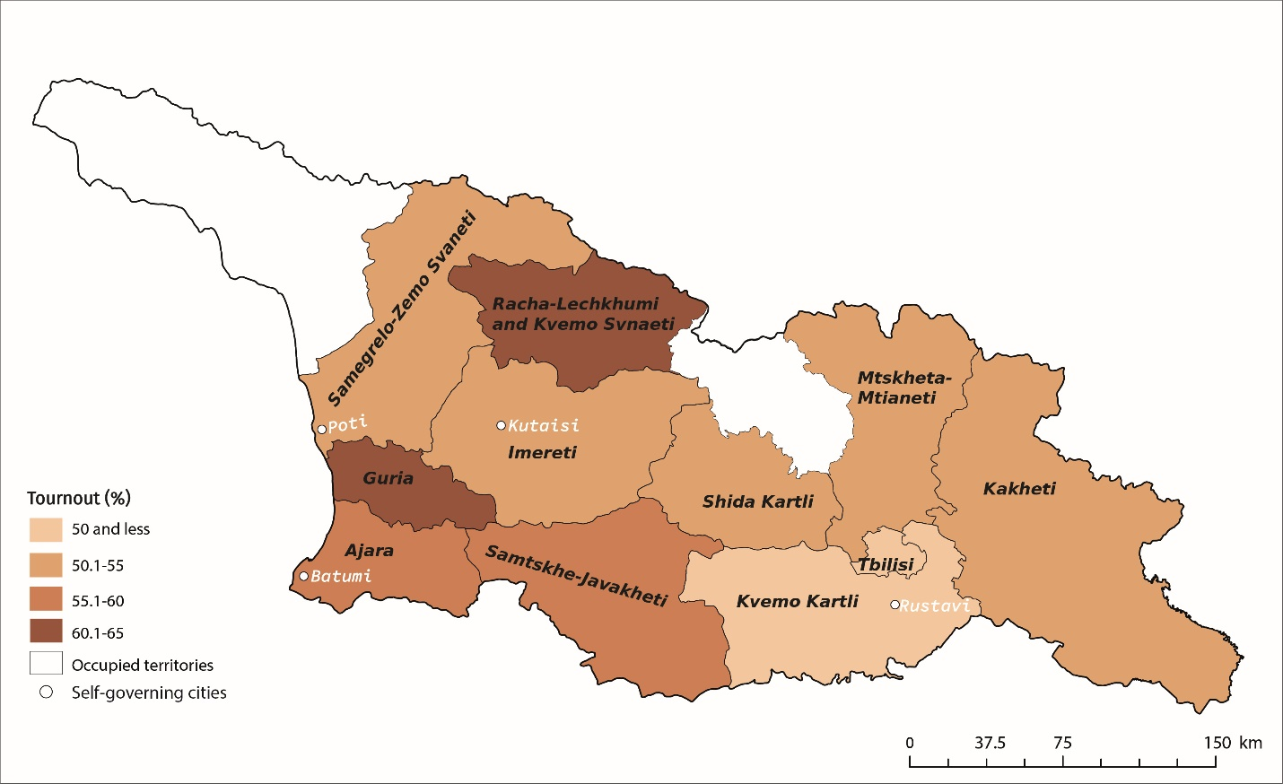
Own work based on data provided by the following source: Voter Turnout, Municipal Elections (2021), Central Election Administration. https://cesko.ge/en/archevnebi/2021/munitsipalitetis-organota-2021-tslis-archevnebi/amomrchevelta-aqtivoba

In two recent municipal elections VT increased by eight percent points in Javakheti (part of Samtske Javakheti region), which is predominantly populated by ethnic Armenians. Voters are still passive in Kvemo Kartli (47%). The latter is explained by the fact that overwhelming majority of registered voters here are ethnic Azeris, who are actively involved in labour migration, mainly to Azerbaijan, Turkey and Russia.
Compared to 2017 elections of local self-government bodies, VT considerably increased in large (self-governing) cities. This was particularly notable in Batumi and Rustavi (by 14 and 12 percent points respectively). However, electorates of these cities are rather passive than that of rural areas. Since 2012, capital Tbilisi also recorded low turnout; however, in 2021 it increased in all districts, especially in so-called “prestigious districts”, marking 7–10% difference with peripheries.
The study once again confirmed that western Georgia is more active than the eastern. In addition, electorate of highlands (e.g., Zemo Svaneti, Racha-Lechkhumi, Upper Ajara) is traditionally more active.
Figure 3
2021 Local Elections in Georgia: Correlation between Voter Turnout and Number of Registered Voters
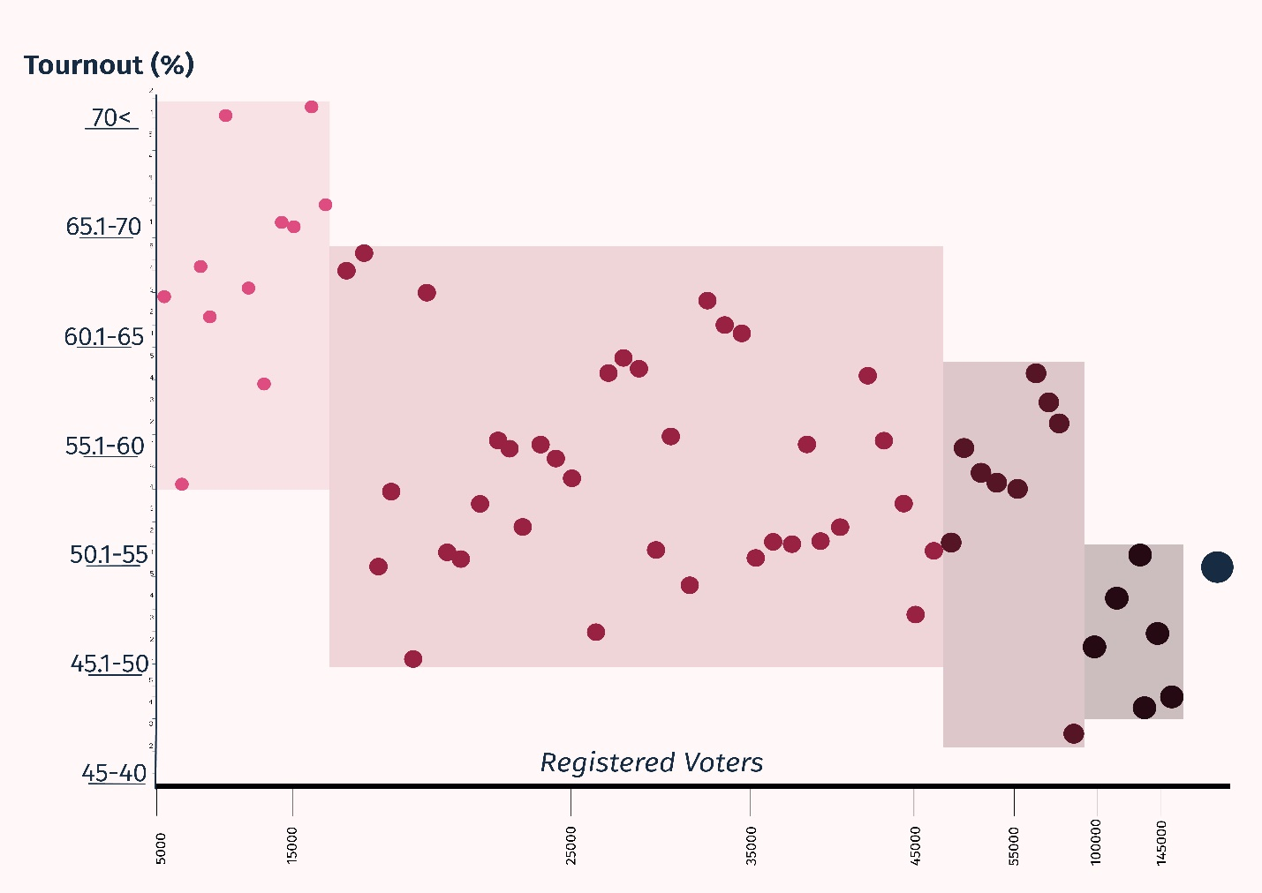
Own work based on data provided by the following sources:
Results, Municipal Elections (2021), Central Election Administration. https://archiveresults.cec.gov.ge/results/20211030/#/en-us
Voter Turnout, Municipal Elections (2021), Central Election Administration. https://cesko.ge/en/archevnebi/2021/munitsipalitetis-organota-2021-tslis-archevnebi/ amomrchevelta-aqtivoba

As illustrated by the above chart, VT is higher in smaller municipalities. There are 12 municipalities in Georgia with less than 20,000 voters. In 10 of them VT was over 60%. On the other hand, there are seven municipalities where number of voters exceeds 70,000: only in one of them VT was over 50%. Rural and urban population have different electoral behavior in Georgia. Rural electorate is characterized by higher voter turnout, which is conditioned by diverse social reasons. It is worth of mentioning that a phenomenon of social solidarity (social identity) described in previous chapter of the paper is applicable to Georgia: voters residing in small places (in our case, small municipalities) are rather active in voting (see figure 3).
One of the goals of the study was to find out if there is a correlation between the size of election district (a number of participating voters) and diversity of elected political parties in Sakrebulos. 2021 elections revealed some inconsistent situation. On the one hand, we have highest diversification in four minor municipal councils (Dusheti, Kazbegi, Lentekhi and Tsageri), each being represented by 6–8 parties (see figure 4). Notably, all these municipalities are located in highlands, and all of them, except Dusheti, have 3–4 thousand voters. On the other hand, it is Tbilisi, country’s largest city, that has higher number of partis (six) represented in its Council.
To analyze the above, we need to consider two aspects: Tbilisi is the largest city not only in terms of population size (around 28% of all voters), but also most important one from social and political standpoint. Headquarters of political parties, media companies, NGOs, and different interest groups are located here. It always has been Georgia’s most democratic, pluralistic, and at the same time, oppositional center. In 2021 elections GD and UNM together received 68.4% of the vote in Tbilisi, while in other regions their combined vote stands above 75%. Therefore, it is logical that Tbilisi Council has rather diversified political spectrum represented.
As for diversity of political parties in minor municipalities, this can be explained by social structure of Georgia’s rural settlements. In small places social identity is specific and it effects electoral behavior of group members (e.g., Fowler & Kam, 2007). “Social affiliation” (Ben-Bassat & Dahan, 2012) creates “social pressure” that makes people to participate in elections (Hoffman-Martinot, 1994; Wirth, 1938). In Georgian villages, especially in highlands, personal relations are strong, which compels member of a social group to engage in elections if kins, friends or neighbors run as parliament or local council candidates, and vote for them. In short, in rural areas “voting is a civic duty” (Riker & Ordeshook, 1968; Overbye, 1995).
Figure 4
2021 Local Elections in Georgia: Correlation between Voter Turnout and Number of Parties in Sakrebulos
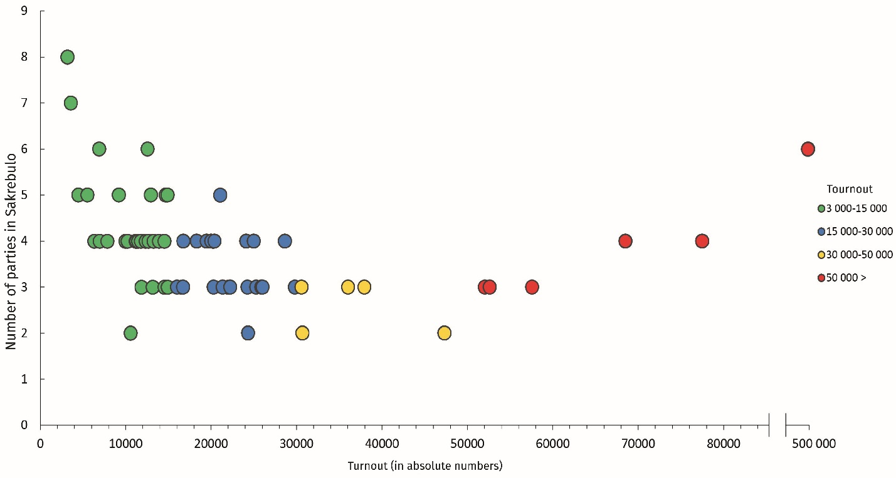
Own work based on data provided by the following sources:
Results, Municipal Elections (2021), Central Election Administration. https://archiveresults.cec.gov.ge/results/20211030/#/en-us
Voter Turnout, Municipal Elections (2021), Central Election Administration. https://cesko.ge/en/archevnebi/2021/munitsipalitetis-organota-2021-tslis-archevnebi/amomrchevelta-aqtivoba

Conclusions
2021 local elections attained particular weight due to the political situation in the country, leveling up with parliamentary elections by its importance. Prior to 2021, VT in municipal elections had never exceeded 50%. Compared to previous (2017) municipal elections, VT considerably increased in 9 out of 11 administrative regions of the country.
Analysis of Georgia’s parliamentary elections allows to single out two main factors that effects VT: mass emigration of late 1990s and early 2000s has caused notable decline in VT, while since 2021 VT varies depending on political odds that are at stake (Gachechiladze & Gogsadze, 2021, p 223). Analysis of 2021 local elections confirmed that the “political stakes” is the most influential factor for higher turnout.
Georgia’s urban and rural population have different electoral behavior and in “urban-rural cleavage” the rural electorate is characterized with higher turnout.
There is a negative correlation between the size of municipal electorate and VT. Municipalities with smaller number of voters have higher turnout. This is a clear case for mountainous areas of Georgia. Socialy homogeneous communities more actively participate in political processes (Geys, 2006, 644–645).
Comparison of two latest local elections reveals that voters have become more engaged in large cities, however VT there still remains lower than in rural areas. Capital city – Tbilisi remains most oppositional and pluralistic urban center. Tbilisi also has the most passive constituency. It is also an established trend for peripheral residents of the capital city to remain rather indifferent towards elections.
The research revealed an interesting trend in Georgia: bigger variety of parties in local councils (Sakrebulos) is characteristic to the capital city and small municipalities. Tbilisi is a traditional center of pluralism, while in small municipalities phenomenon of “social identity” plays a role. In Georgia’s rural population there is a traditionally strong sense of solidarity, which is being formed though same last name, kinship, or neighborly relations. In minor municipalities support of several dozen voters is enough for a candidate to get a seat in Sakrebulo.
Notable fact is that the election administration considers 2021 municipal elections as a step back compared to 2020 parliamentary elections. Although OSCE – ODIHR Election Observation Mission’s General assessment of the last local elections was positive, in its final conclusions it lists problems and challenges that were inherent to the election process: „wide-spread and consistent allegations of intimidation, vote-buying, pressure on candidates and voters, and an unlevel playing field “(OSCE – ODIHR, 2021). The political system of Georgia is still fluid; therefore, the country leadership urgently needs to strengthen democratic institutions as it aspires European Union membership.

Acknowledgement
The authors express their gratitude to Eleonora Chania, graduate student, Department of Human Geography, Ivane Javakhishvili Tbilisi State University for her assistance in producing the figurs for this paper.

References
A way ahead for Georgia (2021), Proposal by President of the European Council Charles Michel to the representatives of Georgian political parties. https://euneighbourseast.eu/news/publications/a-way-ahead-for-georgia-proposal-by-president -of-the-european-council-charles-michel-to-the-representatives-of-georgian-political-parties/

Bell, J. (2001), The political economy of reform in post-communist Poland, Cheltenham, UK; Northampton, MA: E. Elgar.

Ben-Bassat, A. & Dahan M. (2012), Public Choice, vol. 151, issue 1, 193-214. DOI:10.1007/s11127-010-9742-2
Blais A. & Carty K. (1990), Does proportional representation foster voter turnout? European Journal for Political Research, volume 18, issue 2, 167–81. https://doi.org/10.1111/j.1475-6765.1990.tb00227.x
Blais A. & Dobrzynska A. (1998), Turnout in electoral democracies. European Journal of Political Research, 33, 239–261. https://doi.org/10.1111/1475-6765.00382

Blais A., Massicotte L. & Dobrzynska A. (2003). Why is Turnout Higher in Some Countries than in Others? Elections Canada, www.elections.ca

Blank, R.H. (1974), Socio-economic Determinism of Voting Turnout: A Challenge. The Journal of Politics 36, 731–752. https://doi.org/10.2307/2129253

Cancela, J. & Geys, B. (2016), Explaining voter turnout: A meta-analysis of national and subnational elections. Electoral Studies, Volume 42, 264-275. https://doi.org/10.1016/ j.electstud.2016.03.005
Comsa, M. (2017), Explaining Turnout Decline in Post-Communist Countries: The Impact of Migration. Studia UBB Sociologia, 62 (LXII), 2, 29–60. https://doi:10.1515.subs-2017-0010

Downs, A. (1957), An Economic Theory of Democracy. New York: Harper and Row.

European Council President Makes New Proposal to Georgian Political Parties (2021), Georgia Today, April 19, 2021. https://georgiatoday.ge/european-council-president-makes-new-proposal-to-georgian-political-parties/
Fornos C., Power T. & Garand J. (2004), Explaining voter turnout in Latin America, 1980 to 2000. Comparative Political Studies, 37(8), 909–940. https://doi.org/10.1177/0010414004267981
Fowler, J.H. and Kam, C.D. (2007), Beyond the self: Social identity, altruism, and political participation. The Journal of Politics 69(3), 813-827. https://doi.org/10.1111/j.1468-2508.2007.00577.x
Gachechiladze, R. & Gogsadze, G. (2021), Parliamentary Elections in Georgia: Results and Geographical Peculiarities. European Spatial Research and Policy, vol. 28, #2, 2021, 211-226. https://doi.org/10.18778/1231-1952.28.2.12
Gachechiladze, R., Gogsadze, G., Iashvili, I. & Chkhaidze V. (2021). Voter Turnout in Parliamentary Elections of Georgia: Dynamics and Geography. Environment and Society, Vol.3, Issue 3, 57-82 (in Georgian).

Gegeshidze, A. & De Waal, T. (2021), Divided Georgia: A hostage to Polarization. Carnegie Endowment for International Peace. https://carnegieendowment.org/files/TdW-AG_Future_of_Georgia_Final_Report_-_Polarization.pdf

Gendźwiłł, A. & Steyvers K., 2021. Guest editors’ introduction: Comparing local elections and voting in Europe: lower rank, different kind. . . or missing link? Local Government Studies, Vol. 47, No. 1, 1–10. https://doi.org/10.1080/03003930.2020.1825387
Geostat (National Statistics Office of Georgia), 2022. Population and Demography. https://www.geostat.ge/en/modules/categories/316/population-and-demography
Geys, B., 2006. Explaining voter turnout: A review of aggregate-level research. Electoral Studies 25, 637-663. https://doi.org/10.1016/j.electstud.2005.09.002
Grofman, B., Owen, G., & Collet, C. (1999), Rethinking the Partisan Effects of Higher Turnout: So What's the Question? Public Choice 99(3-4), 357–376. https://doi.org/10.1023/A:1018397327176
GYLA (Georgian Young Lawyers’ Association) (2021), Results of 2021 Self-Government Election Observation of the Polling Day as of 8PM. https://gyla.ge/en/post/2021-2000#sthash.H2AVT8ve.dpbs
Hanspeter, K. (2008), Political Mobilisation, Political Participation and the Power of the Vote. West European Politics 31 (1-2), 147–168.
Henderson, A. & McEwen, N. (2010). A Comparative Analysis of Voter Turnout in Regional Elections. Electoral Studies, 29, 405-416. https://doi.org/10.1016/j.electstud.2010.03.012
Hoffmann-Martinot, V., 1994. Voter turnout in French municipal elections, in: López N. L. (Ed.), Local Elections in Europe. Institut de Ciències Polítiques i Socials, Barcelona, 11–42.
International IDEA, 2021. Institute for Democracy and Electoral Assistance: Turnout Database. https://www.idea.int/data-tools/data/voter-turnout
ISFED (International Society for Fair Elections and Democracy), 2021. 2021 Municipal Elections: Final monitoring report, Tbilisi. https://isfed.ge/eng/2021-adgilobrivi-tvitmmartvelobis/2021-tslis-munitsipalitetis-organota-archevnebis-monitoringis-saboloo-angarishi
Jackman, R.W. (1987), Political institutions and voter turnout in industrial democracies. American Political Science Review , volume 81, issue 2 , 405–423. https://doi.org/10.2307/1961959
Jordan, J. (2017), The Effect of Electoral Competitiveness on Voter Turnout, WWU Honors Program Senior Projects, 43. https://cedar.wwu.edu/wwu_honors/43
Katz, R. (2007), Political Institutions in the United States. Oxford: Oxford University Press.
Kavianirad, M. & Rasouli, M. (2015), Explanation of relationship between Geography and Elections (Electoral Geography). Geopolitics Quarterly, volume: 10, No 4, 93–108.
Kostadinova, T. (2003), Voter Turnout Dynamics in Post-Communist Europe. European Journal of Political Research 42(6), 741–759. https://doi.org/10.1111/1475-6765.00102
Kostelka, F. (2017), Distant souls: post-communist emigration and voter turnout. Journal of Ethnic and Migration Studies 43 (7), p. 1061-1063. https://doi.org/10.1080/1369183X.2016.1227696

Kostelka, F. & Blais, A. (2018), The Chicken and Egg Question: Satisfaction with Democracy and Voter Turnout. PS: Political Science and Politics 51 (2), 370–376. https://doi.org/10.1017/S1049096517002050
Lioy A, & Dawson S. (2020), Competition, stakes, and falling electoral participation in Central Asia and the Caucasus: A comparative analysis. Journal of Eurasian Studies, vol. II (2), 144–157. https://doi.org/10.1177/1879366520928359
National Statistics Office of Georgia (2022), Migration. https://www.geostat.ge/en/modules/categories/322/migration
NDI (National Democratic Institute) Georgia (2021), Limited Long Term Election Assessment 2021 Municipal Elections in Georgia. Election Assessment Report September 1 – November 5, 2021. https://www.ndi.org/2021-georgia-municipal-government-elections
Norris, P. (1999), Introduction: The Growth of Critical Citizens? In Critical Citizens; Global Support for Democratic Governance, ed. P. Norris. Oxford: Oxford University Press.
Oliver, J. E. (2000), City size and civic involvement in metropolitan America. American Political Science Review 94 (2), 361–372.
Organic Law of Georgia: The Election Code of Georgia (2020), https://matsne.gov.ge/en/document/view/1557168?publication=69

OSCE–ODIHR (2022), Georgia: Local Elections, 2 and 30 October 2021. ODIHR Election Observation Mission Final Report. Warsaw. https://www.osce.org/files/f/documents/3/a/ 515364_0.pdf

Overbye, E. (1995), Making a case for the rational self-regarding ‘ethical’ voter and solving the ‘paradox of not voting’ in the process. European Journal of Political Research 27, 369–396.

Pacek, A., Pop-Eleches, & G. Tucker, J. (2009), Disenchanted or Discerning: Voter Turnout in Post-Communist Countries. The Journal of Politics, vol. 71, No. 2, 473–491. DOI:10.1017/S0022381609090409

Parliament Amends Election Code (2021), Civil.ge. https://civil.ge/archives/429721
Radcliff, B. & Davis, P. (2000), Labor organization and electoral participation in industrial democracies. Am. J. Polit. Sci. 44(1), 132–141. https://doi.org/10.2307/2669299
Results, Municipal Elections (2021), Central Election Administration. https://archiveresults.cec.gov.ge/results/20211030/#/en-us
Rose R. (2004), Voter turnout in the European Union member countries. In Voter Turnout in Western Europe since 1945, ed. R Lopez Pintor, M Gratschew, 17–24. Stockholm: Int. IDEA.
Riker, W.H. and Ordeshook, P.C. (1968), A theory of the calculus of voting. American Political Science Review 62, 25–42. https://doi.org/10.2307/1953324
Sichinava, D. (2017), Cleavages, electoral geography, and the territorialization of political parties in the Republic of Georgia, Eurasian Geography and Economics, 58:6, p. 670–690. https://doi.org/10.1080/15387216.2018.1442734
Stockemer, D. (2017), ‘What Affects Voter Turnout?’, Government and Opposition, 52 (4), 698–722. https://doi.org/10.1017 /gov.2016.30
Tullock, G. (1967), Towards a Mathematics of Politics. University of Michigan Press, Ann Arbor.
Vainshow, M. & Guy, J. (2018), Is Higher Turnout Bad for Incumbents, Carnegie Endowment for International Peace. https://carnegieendowment.org/2018/05/07/is-higher-turnout-bad-for_incumbents -pub-76238
Verba, S. & Nie, N. H. (1972), Participation in America: Political Democracy and Social Equality. New York: Harper & Row.
Voter Turnout, Municipal Elections (2017), Central Election Administration. https://cesko.ge/en/archevnebi/2017/2017-tslis-adgilobrivi-tvitmmartvelobis-organota-archevnebi/amomrchevelta-aqtivoba
Voter Turnout, Municipal Elections (2021), Central Election Administration. https://cesko.ge/en/archevnebi/2021/munitsipalitetis-organota-2021-tslis-archevnebi/amomrchevelta-aqtivoba
Wigginton, M., Stockemer, D. & van Schouwen, J. (2019), International Migration and Turnout Bias. Political Science & Politics, 53(1), p. 33-38. https://doi.org/10.1017/S104909651900101X
Wirth, L. (1938), Urbanism as a way of life. American Journal of Sociology 44, 3–24.

